# Position Details

## Administrative Services- CSOF5

|  |  |
| --- | --- |
| The following information is for applicants | |
| Advertised Job Title | CSIRO’s Business and Infrastructure Services (CBIS) Project Coordinator, Capital Works |
| Job Reference | 71298 |
| Tenure | Specified Term of 9 months  Full-time |
| Salary Range | AU$98,735 to AU$106,848 pa + up to 15.4% superannuation |
| Location(s) | Australian Centre for Disease Preparedness (ACDP), Geelong |
| Relocation Assistance | Will be provided to the successful candidate if required |
| Applications are open to | Australian Citizens Only |
| Position reports to the | CBIS Project Director, Capital Works |
| Client Focus – Internal | 60% |
| Client Focus – External | 40% |
| Number of Direct Reports | 0 |
| Enquire about this job | Contact Rod Howard via email at: rod.howard@csiro.au or phone +61 3 5227 5281 |
| How to apply | Apply online at <https://jobs.csiro.au/>  Internal applicants please apply via **Jobs Central**  If you experience difficulties when applying, please email [careers.online@csiro.au](mailto:careers.online@csiro.au) or call 1300 984 220. |

### Role Overview

CSIRO has a complex property portfolio of owned and leased facilities that comprises over 1,000 buildings spread across more than 55 locations within Australia. These scientific and research facilities are diverse both in location and type. CSIRO Business & Infrastructure Services (CBIS) is chartered with managing the services, maintenance and operation of all CSIRO’s scientific and research facilities. CBIS delivers strategic, estate management and capital works functions through its regional and state property management teams supported by its capital works team. CBIS’s strategy and operational activities align with CSIRO’s strategic direction and scientific activities.

The CBIS Project Coordinator will autonomously manage the planning and delivery of medium capital work projects and under the guidance of the Project Manager, support the planning and delivery of major capital works projects including the application of change management principles. Current projects range in value from $1 million - $200 million. These projects include building construction, refurbishment and environmental sustainability works undertaken in a complex environment, with a focus on whole of life capital and operating costs. Future projects may be of greater value. These projects will be primarily based at Geelong.

This position is for a 9-month term. Specifically, this role will be coordinating the commissioning and project closure of the Dry Fire Systems Upgrade as a key focus. In addition to the Dry Fire Upgrade, the role includes assisting with the ACDP Part Life refit, Security Upgrade, or CSIRO Capital Works projects more broadly as dictated by workload and Capital Works team priorities.

This role will be directly accountable for ensuring the project adheres to time, cost and quality requirements and for providing high quality, strategic advice; often in connection with technically challenging issues. In delivering these projects, you will be responsible to the CBIS Project Manager, will operate within the project governance structure and be supported by the capital works project management office (PMO). The role requires the participation in various project activities, including engagement and communication with key internal and external stakeholders and contractors, in a rapidly changing environment to deliver leading edge project outcomes.

The Project coordinator will keep abreast of relevant issues and developments and draw on CSIRO-internal and external expertise in order to provide timely, accurate, specialist advice within the Project often impacting strategic decision making.

This is a security accessed position; applicants must be an Australian citizen. Appointment into the position is subject to the successful applicant holding or having the ability to hold a Negative Vetting 1, Australian Government security clearance.

### Duties and Key Result Areas:

Specific Tasks:

* Receive handover of the Dry Fire Upgrade project and coordinate the completion of works, commissioning, cutover to new system, removal of redundant equipment, information collation and handover, training, defect management, cost accounting and project closure.
* Site based coordination for ACDP Security Upgrade.
* Site supervision and escorting of the ACDP Part Life Refit Contractors.
* Information retrieval for ACDP Part Life Refit Contractors.

General Duties:

* Lead, contribute to, and administer the delivery of medium and major capital works projects, integrating the strategic needs of sound asset management principles and science objectives to deliver a value driven whole of facility life outcome.
* Manage the administrative aspects of projects including document management, minute taking, report writing, preparation of presentations and organisation of meetings.
* Lead the successful delivery of concurrent project activities with a focus on whole of life, client engagement, consultation and change management.
* Develop, manage and administer, end-to-end project delivery ensuring the project delivers on time, on budget, with compliant and fit-for-purpose facilities.
* Establish and maintain collaborative and proactive working relationships with the B&IS ACDP Technical team, Capital Works team and key stakeholders, to deliver high quality outcomes.
* Oversee and report on project performance to ensure that solutions provided continue to meet the needs of stakeholders, are cost effective and sustainable, appropriately recognise and address risks, and are aligned with project objectives.
* Provide leadership, motivation and guidance to team members and peers, establishing strong team culture based on performance, development and a demonstrated commitment to displaying the highest standard of ethical behaviour and integrity aligned with the principles of CSIRO Values.
* Manage significant risks and issues, often in ambiguous situations, by evaluating and interpreting complex information and developing creative solutions and contingencies.
* Communicate openly, effectively and respectfully with all staff, clients and suppliers in the interests of good business practice, collaboration and enhancement of CSIRO’s reputation.
* Work collaboratively as part of a multi-disciplinary, often regionally dispersed research team, and business unit to carry out tasks in support of CSIRO’s scientific objectives.
* Adhere to the spirit and practice of CSIRO’s Code of Conduct, Health, Safety and Environment procedures and policy, Diversity initiatives and Making Safety Personal goals.
* Other duties as directed.

## **Required Competencies:**

* **Teamwork and Collaboration:** Cooperates with others to achieve organisational objectives and may share team resources in order to do this. Collaborates with other teams as well as industry colleagues.
* **Influence and Communication:** Uses knowledge of other party's priorities and adapts presentations or discussions to appeal to the interests and level of the audience. Anticipates and prepares for others reactions.
* **Resource Management/Leadership:** Sets up and maintains effective and efficient work teams and manages performance and resources, to achieve objectives. Chooses appropriate management strategies and communication styles to maintain high levels of motivation and productivity. Gives feedback for development purposes and provides support and direction for improvement.
* **Judgement and Problem Solving:** Investigates underlying issues of complex and ill-defined problems and develops appropriate response by adapting/creating and testing alternative solutions.
* **Independence:** Plans, sets and works to meet challenging standards and goals for self and/or others. Recognises where endeavours will make the most impact or difference, decides on desired outcome and sets realistic goals to reach this target.
* **Adaptability:**Copes with ambiguity or situations that lack clarity. Adapts readily to changing circumstances and new responsibilities (which may include activities outside own preferences) in the interests of achieving team objectives. Recognises the need for and undertakes personal development as a result of changes.

## **Selection Criteria**

#### Essential

*Under CSIRO policy only those who meet all essential criteria can be appointed.*

1. Knowledge of Contractor Management in the context of the ACDP facility and/or fire detection and emergency warning systems, Safe Work Management Systems, and contract administration.
2. Well-developed understanding of project management methodologies, contract management, health and safety legislation, and Commonwealth procurement requirements including how these functions integrate with capital works activities in a Commonwealth environment.
3. Proven ability to think and act strategically, work independently, identify and manage risks, and identify and evaluate opportunities that optimise project outcomes in line with CSIRO’s strategic direction.
4. Demonstrated ability to lead and influence internal and external stakeholders through high level communication skills that can be adapted to the target audience, to achieve project outcomes.
5. Demonstrated ability to lead, coordinate and manage a multi-disciplinary team comprised of internal and external project management and consultant personnel, to achieve project outcomes.
6. An understanding of Government processes (in particular, planning systems and controls, project planning and delivery).

## **Desirable:**

1. Experience in providing administrative support in the planning and delivery of complex capital works projects.
2. Experience in O2D and SAP financial reports, or demonstrate experience in other project/asset based financial systems.
3. Knowledge of ACDP Permit systems.

Special Requirements

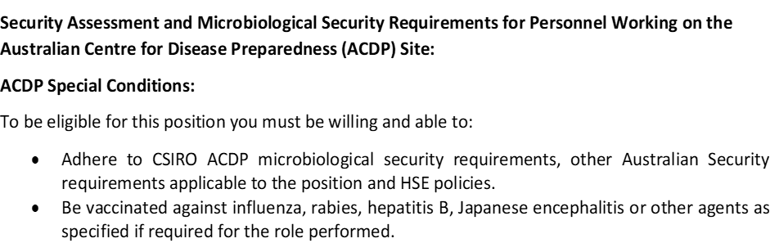



Personnel must abide by Occupational Health, Safety and Environment regulations. Safety signs and directives issued by CSIRO personnel must always be complied with.

## **About CSIRO:**

We solve the greatest challenges through innovative science and technology. To find out more visit us [online](http://www.csiro.au/)!

CSIRO is a values-based organisation. We expect our employees to demonstrate behaviours aligned to our values of:

• People First • Further Together • Making it Real • Trusted

Find out more about the CSIRO [Australian Centre for Disease Preparedness](https://www.csiro.au/en/Research/Facilities/AAHL)