Position Description –

Australia’s National  
Science Agency

Research Director, Human Health

Information for applicants

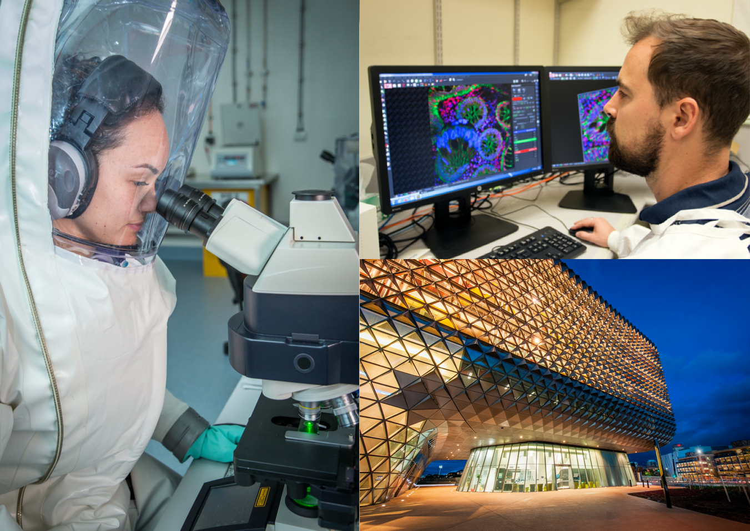

About CSIRO

The Commonwealth Scientific and Industrial Research Organisation (CSIRO) is one of the world’s largest and most successful publicly funded research and development organisation with over 50 locations across Australia and internationally.

CSIRO is committed to complementing its world-class science capabilities with outcome-focused research that will generate economic, environmental, and social benefits for Australia in a global context.

CSIRO’s mandate is to deliver research that provides innovative solutions for industry, government and the community. The research effort is therefore mission-directed, and impact-focussed.

Overview of CSIRO’s Health & Biosecurity (H&B) Business Unit

Australia’s health and biosecurity sectors are under increasing pressure from multiple existing and emerging threats. For example, emerging infectious diseases are a current and ongoing risk that require urgent attention, and as our population ages and the burden of chronic disease increases, we need to consider new ways of delivering healthcare. With this in mind, the H&B Business Unit’s goal is to collaboratively deliver impact that drives the transformation of Australia’s health and biosecurity sectors, improving prevention, detection and responses to health and biosecurity threats.

This Business Unit focusses R&D around building Australia’s resilience to health and biosecurity megashocks; supporting the technological and digital transformation of healthcare and biosecurity systems; and improving health and wellbeing of all Australians. It is comprised of three Research Programs that span the biosecurity, health systems and human health sectors, with approximately 295FTE located across Australia and Europe and an annual budget of approximately $62M.

About the Human Health Program and the Role

Following a strategic review, CSIRO is seeking to appoint a Research Director to lead the newly formed Human Health Research Program. This research program seeks to create national and global impact by delivering R&D that drives a shift toward improved preparedness against human health threats, and enhanced quality of life for all Australians across their lifespan. The program’s critical focus areas are:

* R&D to increase biothreat preparedness and resilience to emerging infectious disease;
* Innovation, validation, and clinical integration associated with novel diagnostic tools; and
* Development and validation of precision solutions that enable proactive health management.

Enhancing this program’s impact is our role as a trusted advisor to the Australian population, to government and across the health ecosystem.

The program comprises of approximately 90 multi-disciplinary scientists and support staff who are predominantly located in Sydney (NSW), Geelong (VIC), Canberra (ACT) and Adelaide (SA). The program has annual budget of approximately $20M, derived from a blend of internal, industry and government sources. Reporting to the Director of the Health & Biosecurity Business Unit, the Research Director sets the vision and strategy for the Program and is responsible for leading a portfolio of multi-disciplinary, collaborative research projects and strategic initiatives that deliver on the goals of the Business Unit.

The Research Director of the Human Health Program must be a strategic and collaborative leader with significant change management experience. It is essential that the Research Director has demonstrated strong links with relevant industry partners across the health sector, government agencies, universities and health and medical research institutes. Demonstrated business/commercial acumen and an extensive and relevant track record in translation and commercialisation of health sector R&D is essential. A national/international reputation and influence in a relevant research field is expected.

The Research Director is responsible for the management of a diverse range of capability, staff development, strategy development and financial outcomes. They will form part of the H&B Leadership Team and be accountable for the delivery of specific elements of the Business Unit’s overall impact, science, and financial objectives, as well as the ongoing development of its strategy. The Research Director works with the Leadership Team to realise the Business Unit’s vision and works collaboratively with other Research Directors and researchers across the broader organisation in developing an agenda for tackling the nation’s greatest challenges.

The Program is embarking on significant growth in:

* Human diagnostics capabilities;
* R&D associated with infectious disease resilience and antimicrobial resistance;
* Establishing a presence in the NSW Westmead Health Precinct;
* Embracing Lab of the Future operating and business models;
* Growing Indigenous-led science and achieving Indigenous health impacts; and
* Intellectual property pipeline.

The Research Director will use their relevant health sector knowledge and expertise, and work in partnership with industry and government, to realise the growth opportunities.

Key result areas and duties

Impact science leadership

* Sustain and enhance the R&D culture of science excellence, creativity, innovation and flexibility;
* Ensure that the Program’s science is globally competitive and addresses meaningful problems in the market;
* In consultation with research partners and research users, lead the science strategy and build capacity to innovate for science discovery;
* Identify new opportunities and markets in Australia and overseas, and engage key stakeholders and clients to build support for investment in opportunities;
* Integrate science with project and impact delivery through an effective “Path to Impact” framework;
* Be accountable for scientific performance, including citations, patents, students and research that has been commercialised;
* Catalyse innovation – form/support science networks, review and sponsor exploratory and science capability development projects;
* Build a pipeline of contracts (3 to 5-year focus) including identification of cross-Business Unit opportunities and manage the Program’s portfolio of Intellectual Property;
* Support the BU’s contribution to CSIRO strategy through investments in Missions, Future Science Platforms, and the Indigenous Science Program;
* Guide the set of projects needed to deliver against Health & Biosecurity’s strategy;
* Support the Science Director in the Business Unit Science Reviews.

Engagement and partnerships

* Build strategic relationships through engagement with the domestic and international health and biosecurity ecosystem including industry, academia, and government.
* Produce or support the production of high quality scientific and/or engineering papers suitable for publication in quality journals and for presentation at national and international conferences.
* Communicate openly, effectively, and respectfully with all staff, customers and suppliers in the interests of good business practice, collaboration and enhancement of CSIRO’s reputation.

Resource leadership

* Lead and manage the Program’s financial resources, people, infrastructure and other assets to ensure their effective and efficient use.
* Ensure effective management of physical infrastructure and resources in an environmentally sustainable way.
* Ensure best practice governance and management of commercial activities and intellectual property in the platform.
* Manage financial performance of activities within the platform.
* Manage delivery against milestones and quality standards.
* Contribute to the development of science plans for future infrastructure

Capability leadership

* Strive for “Zero Harm” (physical and psychological) and actively promote a healthy, safe and environmentally sustainable workplace, in doing so model appropriate and professional behaviour in the workplace and manage people matters proactively;
* Inspire staff and sustain and nurture awareness of the Health & Biosecurity business unit’s vision, science quality and impact in the broader Australian community;
* Attract, develop and retain world class talent which meet current and future needs - in the short and longer term;
* Support the Program’s Group and Team Leaders to build effective teams and groups, manage career development for staff and succession planning;
* Build the long‐term science capability to support the delivery of the Program’s research and impact, including forecasting demand, monitoring science trends and stakeholder needs, and building a high-performance culture;
* Effectively lead change initiatives across the Program and the Business Unit.
* Model appropriate and professional behaviour and manage people matters proactively

Key capabilities

**CSIRO is a values-based organisation**

**People First**: We put the safety and wellbeing of our people above all else, and we know that diversity is the compass to navigate innovation. (Respect, Caring, Inclusive)

**Trusted**: We earn trust everywhere, because we deal only in facts, and we operate with unwavering integrity. (Partnering, Cooperative, Humble)

**Further Together**: We collaborate widely and generously to boldly take on challenges that are bigger than ourselves. (Curious, Adaptive, Entrepreneurial)

**Making it Real**: We don't just do research – we deliver solutions that create change in our world. (Accountable*, Authentic, Courageous*)

**Experience**

* Developed, implemented and successfully delivered a portfolio of relevant research, including financial and risk management;
* Demonstrated leadership and excellence in a relevant field of research, as demonstrated by an international research reputation and credibility, and with a strong track record of uptake, adoption and impact delivered to industry and other end users;
* Led large multi‐disciplinary teams across several science areas and/or geographic locations;
* Involvement in strategic planning and implementation of change;
* Demonstrated experience in growing, reshaping and revitalising a capability area.

**Personal and leadership attributes**

* Resilience
* Emotional intelligence
* Ability to navigate complexity
* Collegial
* Ability to optimise diversity
* Ability to foster team play

**Organisational Knowledge (Internal applicants only)**

* Code of Conduct;
* The vision of Health, Safety & Environment;
* CSIRO Strategy
* Relevant internal and external key stakeholder networks;
* Specific knowledge of the portfolio domain (sector, industry);
* Deep working knowledge of specific science and impact domains in which science capabilities can be applied to deliver maximum impact;
* Governance Framework, CSIRO Delegations and Authorities manual and CSIRO Policies, Standards and Procedures.

Selection criteria

***Pre-requisite:***

* A doctorate and/or equivalent research experience in medical diagnostics/technologies; infectious diseases and pandemic preparedness; or human health, combined with significant impact driven research leadership experience.

***Essential Criteria:***

1. Evidence of strong industry and government engagement with the health sector, and strategic relationship management that grows new impact opportunities and supports positive and sustainable commercial outcomes.
2. Demonstrated leadership and excellence in a relevant field of science or engineering, as demonstrated by high‐quality peer reviewed, published research including an established international research reputation and credibility.
3. Evidence of successful leadership of a strategic project portfolio, from emerging science opportunities to health and medical technology translation and commercialisation, in alignment with national and global research challenges.
4. Evidence of high impact engagement within a leadership team, and demonstrated experience leading a multi-disciplinary research team high levels of co-operation and collaboration. This is strengthened by demonstrated experience developing and implementing inter- or intra- organisational strategic collaborations that address national and international challenges in the health and biosecurity domains.
5. Demonstrated ability to establish and engage productive teams, manage performance, undertake strategic planning, drive and implement change to operationalise the strategic vision for staff.
6. Demonstrated track record in leading a complex, multi-site business including managing financial and physical resources and creating a safe and healthy workplace.
7. Demonstrated knowledge and understanding of health, medical technology trends, and pandemic preparedness e.g. growth areas, market accessibility, in the global market.

***Desirable Criteria:***

* A record of science innovation and creativity, plus the ability to apply well developed research skills to scientific investigations of significant consequence.

Conditions of employment

* An attractive senior salary package will be offered to the successful candidate.
* CSIRO offers four weeks recreation leave and 15 days sick leave and carer’s leave apply.
* CSIRO has a flexible working policy.
* Regular interstate and some international travel will be required for this role.
* Relocation will be provided to the successful candidate where required.
* This position is for a three-year fixed term.

Location

The preferred locations for this role are Adelaide (SA), Sydney (NSW), Geelong or Melbourne (Vic), other capital cities considered.

Apply

**Contact**

For further information about this role contact:

Terri Ward at terri@towardco.com or call +61 447 667 439.

**How to Apply**

As part of their application, candidates are requested to provide the following in Microsoft Word format:

* **Curriculum Vitae**
* **Cover Letter –** outlining the motivation and relevant capabilities and experience you could bring to this role. This document should not be longer than two pages.
* **Contact details for three Referees –** Referees will only be contacted after prior consultation with the candidate. It is the candidate's responsibility to ensure that their referees are willing to provide reports when contacted by CSIRO.
* **Date of commencement –** An indication of the earliest date on which the candidate could commence in the position.

**PLEASE SUBMIT YOUR APPLICATION DIRECTLY TO TERRI WARD AT** [**terri@towardco.com**](mailto:terri@towardco.com) **QUOTING CSIRO CHBHH21 IN THE SUBJECT LINE.**

**PLEASE DO NOT APPLY VIA THE CSIRO WEBSITE.**

**Applications close 11pm 20 September 2021**

Flexible Working Arrangements

We work flexibly at CSIRO, offering a range of options for how, when and where you work. Talk to

us about how this role could be flexible for you. [Work life balance](https://www.csiro.au/en/Careers/The-CSIRO-Experience/Balance).

Diversity and Inclusion

We are working hard to recruit diverse people and ensure that all our people feel supported to do

their best work and feel empowered to let their ideas flourish. [Diversity and Inclusion Strategy](https://www.csiro.au/en/About/Policies-guidelines/Working-at-CSIRO/Diversity-strategy).

We are committed to the safety and wellbeing of all children and young people.

|  |  |  |
| --- | --- | --- |
| As Australia’s national science agency and innovation catalyst, CSIRO is solving the greatest challenges through innovative science and technology.  CSIRO. Unlocking a better future for everyone.  Contact us  1300 363 400  +61 3 9545 2176  csiro.au |  |  |