Position Details

Research Management - CSOF6
The following information is for applicants
Advertised Job Title | Director, National Biodiversity DNA Library
Job Reference | 77655
Tenure | Specified term of 2 years (with possibility for extension)  Full-time
Salary Range | AU$115k - AU$135k per annum, plus up to 15.4% superannuation
Location(s) | Black Mountain (Canberra) ACT  (other locations may be considered by negotiation)
Relocation Assistance | Will be provided to the successful candidate if required
Applications are open to | - Australian or New Zealand Citizens currently residing in Australia  - Australian Permanent Residents currently residing in Australia  - Australian temporary residents who are currently residing in Australia and have the right to work for the expected duration of the term (at least to end of December 2023, with no requirement for sponsorship
Position reports to the | Director, Environomics Future Science Platform
Client Focus – Internal | 80%
Client Focus – External | 20%
Number of Direct Reports | TBC
Enquire about this job | Oliver Berry via email Oliver.Berry@csiro.au
How to apply | Apply online at https://jobs.csiro.au/  Internal applicants please apply via Jobs Central  If you experience difficulties when applying, please email careers.online@csiro.au or call 1300 984 220.

Role Overview
The Director, National Biodiversity DNA Library (NBDL) leads a team including molecular biologists, bioinformaticians, data analysts, and digitisation experts, and works extensively with the collections and taxonomic community, plus end-users of environmental information to deliver this significant national asset. The Director provides leadership, devises strategy, and actively communicates with a broad range of stakeholders including a steering group, partners, funders, end users and the public.
The NBDL is a globally unique and significant data infrastructure that will transform the effectiveness of environmental monitoring in Australia and support industries including fisheries, agriculture, biosecurity, environmental management, and tourism.
The NBDL will generate reference DNA sequences for all named Australian species and is powered by technology developed by CSIRO’s Environomics Future Science Platform. These reference DNA sequences will enable a variety of molecular species identification and cutting-edge biodiversity survey methods, e.g., DNA barcoding of individual specimens, meta-barcoding and eDNA surveys.
DNA-based biological surveys are poised to revolutionise the speed, scale, and accuracy of how we monitor Australia’s natural environment. However, they rely on access to a reference library of DNA sequences from known species, and currently this library is very incomplete and dispersed. This means that most species go undetected because their DNA sequences can’t be matched in the library. This long-standing global problem is now solvable using a world-leading technology created by CSIRO.
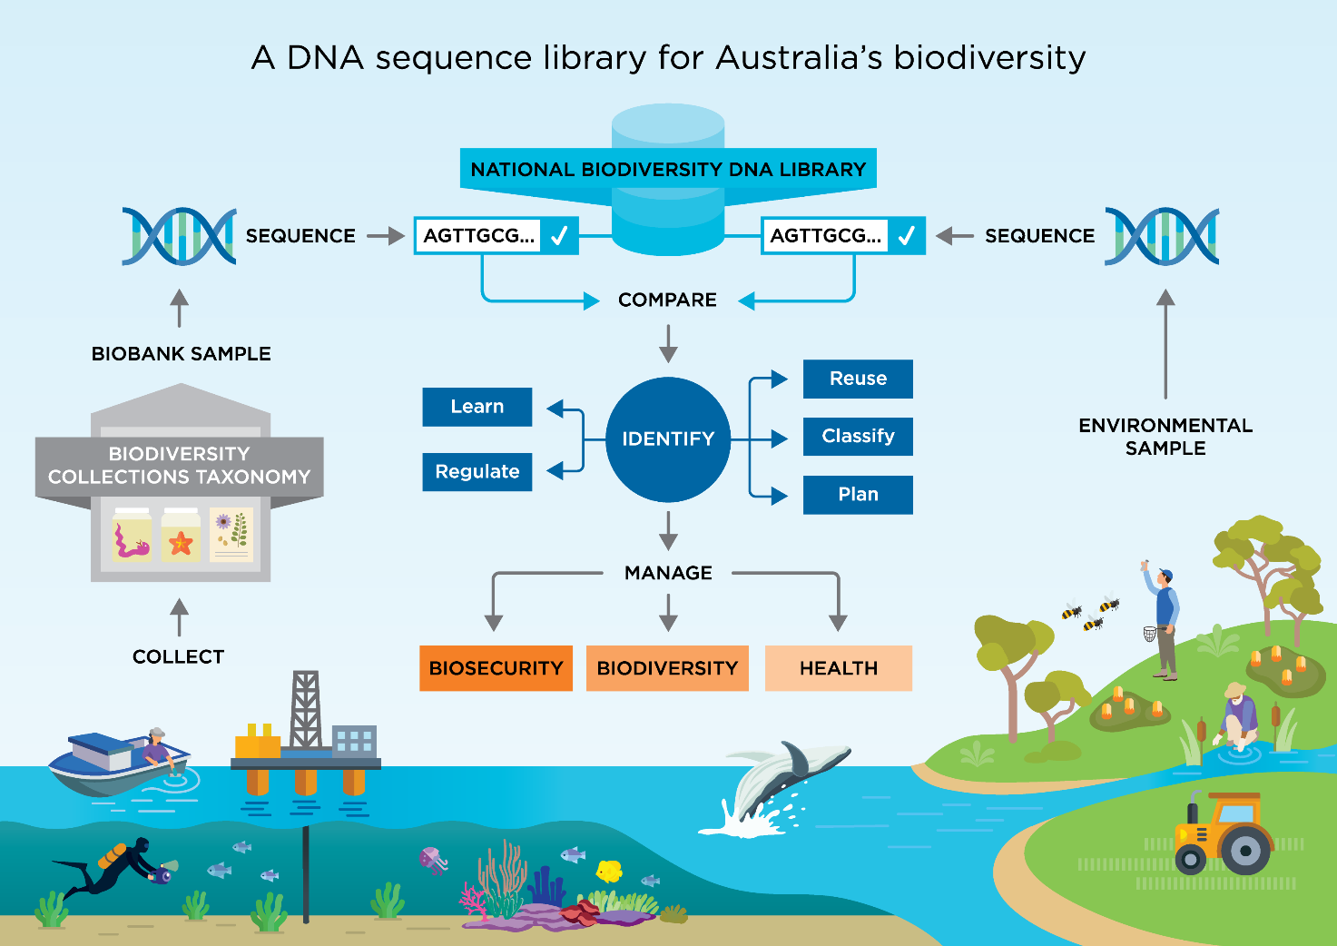

Duties and Key Result Areas
- Lead a multidisciplinary team of scientists to deliver the National Biodiversity DNA Library.
- Work with a steering committee to lead the planning of sequencing campaigns focused on taxonomically, regionally, or thematically defined groups of organisms. This will include establishing principles for the identification and design of campaigns.
- Build and maintain strategic partnerships, including with governments, industry, and NGOs. Of particular importance is establishing and maintaining partnerships with Australia’s taxonomic and collection communities.
- Play a lead role in securing project funds through interactions with partners.
- Communicate the mission, achievements, and impacts of the NBDL to partners, government, industry, and other stakeholders, including the public.
- Work with the NBDL’s technical lead and broader team to continually improve the efficiency of workflows and evaluate infrastructure needs.
- Work with the steering committee and broader team to establish data, identification and metadata standards for the acceptance of records into the NBDL.
- Ensure that the NBDL delivers data and analytical resources that meet the needs of end-users in the biodiversity and biosecurity monitoring sectors.
- Work with the Atlas of Living Australia, CSIRO’s Data Access Portal, and other environmental data facilities to ensure that the NBDL adopts data handling practices that facilitate data exchange and interoperability with other local and international data infrastructures.
- Ensure that protocols are put in place to track NBDL data use.
- Communicate openly, effectively, and respectfully with all staff, clients and suppliers in the interests of good business practice, collaboration and enhancement of CSIRO’s reputation.
- Adhere to the spirit and practice of CSIRO’s Values, Code of Conduct, Health, Safety and Environment procedures and policy, Diversity initiatives and Zero Harm goals.

Selection Criteria

Essential
Under CSIRO policy only those who meet all essential criteria can be appointed.
- A doctorate or equivalent experience in a relevant molecular biology discipline area such as biodiversity or biosecurity genomics, together with relevant practical experience.
- Demonstrated experience leading large multi-disciplinary scientific programs, ideally with an end-user focus.
- High level written and oral communication skills with a proven ability to represent science concepts to both professional and public audiences.
- Demonstrated experience building partnerships with external (industry and government) organisations, including the acquisition of funding.
- A record of innovation and creativity in achieving objectives.

Desirable
- Experience with the application of DNA sequence technology to biological surveys (e.g., eDNA, meta-barcoding, DNA barcoding).
- Experience working with natural history collections and the taxonomic science community.

Required Competencies
- Teamwork and Collaboration: Cooperates with others to achieve organisational objectives and may share team resources in order to do this. Collaborates with other teams as well as industry colleagues.
- Influence and Communication: Identifies critical stakeholders and influences them via an influential third party, for example through an established network, to gain support for sometimes contentious, proposals/ideas.
- Resource Management/Leadership: Sets up and maintains effective and efficient work teams and manages performance and resources, to achieve objectives. Chooses appropriate management strategies and communication styles to maintain high levels of motivation and productivity. Gives feedback for development purposes and provides support and direction for improvement.
- Judgement and Problem Solving: Anticipates and manages problems in ambiguous situations. Develops and selects an appropriate course of action and provides for contingencies. Evaluates, interprets and integrates complex bodies of information and draws logical conclusions, synthesises proposals and defends options with reasoned arguments.
- Independence: Assesses the risk and opportunity of identified strategies, options and actions. Overcomes problems and setbacks in achieving goals. Invariably includes consideration of value-added future impact on bottom line when determining the optimal and efficient use of resources.
- Adaptability: Demonstrates flexibility in thinking and adapts to and manages the increasing rate of organisational change by adjusting strategies, goals and priorities.
Special Requirements
The successful candidate will be asked to obtain and provide evidence of a National Police Clearance or equivalent. Please note that individuals with criminal records are not automatically deemed ineligible. Each application will be considered on its merits.

About CSIRO
We solve the greatest challenges through innovative science and technology. Visit CSIRO Online and National Research Collections Australia for more information.
CSIRO is a values-based organisation. In your application and at interview you will need to demonstrate behaviours aligned to our values of:
- People First
- Further Together
- Making it Real
- Trusted

