# Position Description

Research Director –

Sustainability Program, Agriculture and Food

Information for applicants

## 

Australia’s National  
Science Agency

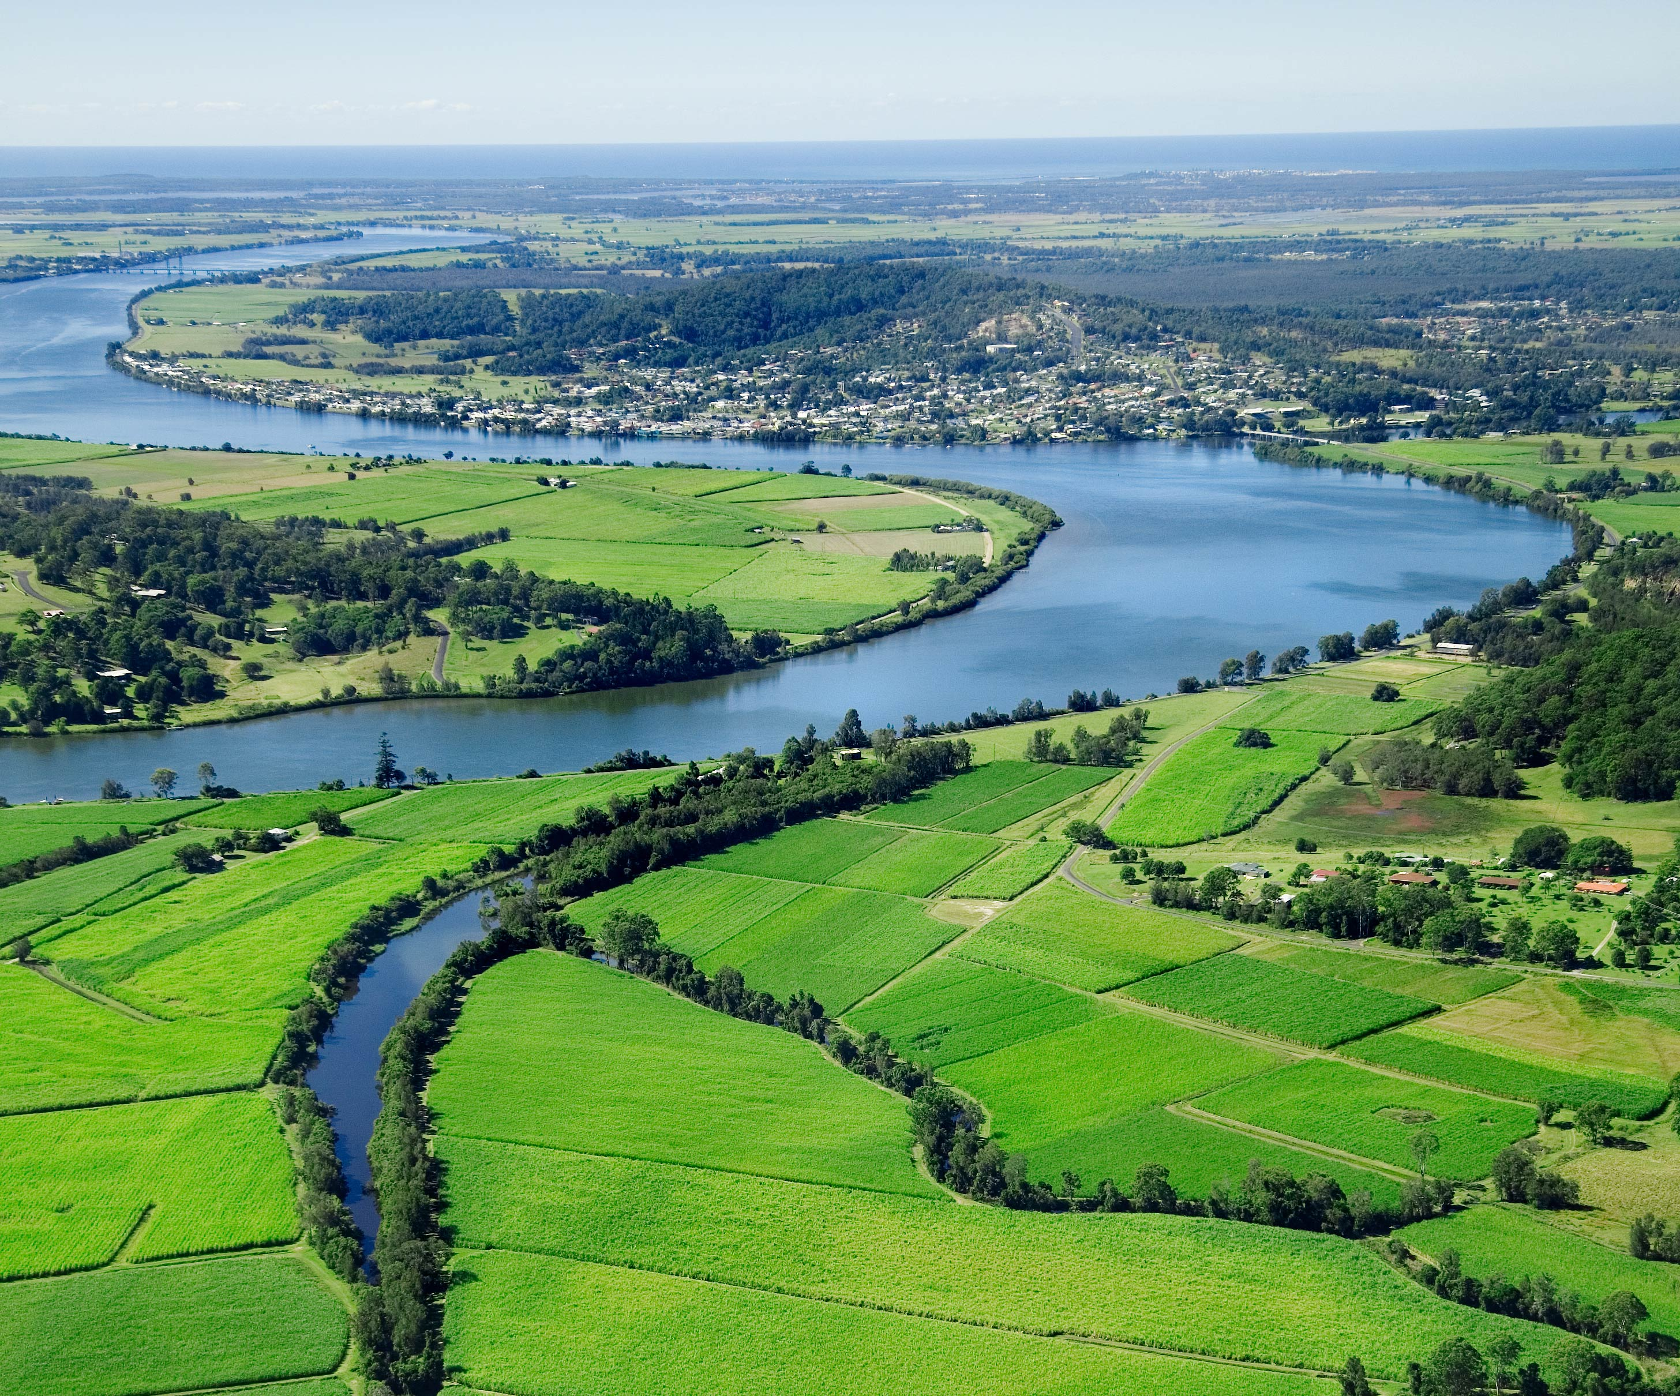

## About CSIRO

The Commonwealth Scientific and Industrial Research Organisation (CSIRO) is one of the world’s largest and most successful publicly funded research and development organisation with over 50 locations across Australia and internationally.

CSIRO is committed to complementing its world-class science capabilities with outcome-focused research that will generate economic, environmental and social benefits for Australia in a global context.

## CSIRO Agriculture and Food

CSIRO Agriculture and Food is helping to improve productivity, profitability and sustainability in cropping, livestock production, aquaculture, horticulture and the food industry.  
  
CSIRO Agriculture and Food is Australia’s most significant science investment for its key primary production activities including cropping, meat and livestock, aquaculture, horticulture, food safety and processing, and value-adding.  These industries underpin >$40B of food and fibre production, $97B of domestic food and beverage processing, and >$30B of agricultural exports per annum in Australia while providing stewardship for at least 60 per cent of the Australian landscape.  The growing global population requires a 70 per cent increase in food supply in the coming 30 years, which needs to be achieved with a sustainable natural resource base. Our research improves the productivity, profitability and sustainability of Australia’s agricultural and food sectors, and we deliver transformative technologies, management and knowledge systems to stabilise food security and primary production systems in our region and globally. CSIRO Agriculture and Food operates nationally and internationally, focussing on solutions to long-term and complex problems, at scale and over sustained timeframes, and is the hub for Australia’s food and agricultural science and innovation system. Using multi-disciplinary approaches, and together with our partners, we are world leaders in food and agricultural innovation.  
  
Agriculture & Food’s purpose is to help deliver to key innovation challenges:

* Enhance the resilience, sustainable use and value of our agri-food environments, including by mitigating and adapting the impacts of climate and global change.
* Achieve sustainable regional food security and grow Australia’s share of premium agri-food markets.
* Enhance health through novel food and ingredients and trusted supply chains.
* Create Australia’s future agri-food industries and jobs by catalysing the innovation ecosystem.
* Regional security through improved food systems.

This will be achieved through seven key impact areas:

* **Secure food systems**: Australia’s role in securing global food systems, with a focus on the Asia-Pacific
* **Healthy foods**: Novel ingredients and production systems for healthier diets
* **Trusted supply chains**: Technology that enables growth in export value of premium agri-foods
* **Resilient farming systems**: Innovative animal and plant-based farming systems driving profitability and sustainability
* **High-value protein**: Growing plant and animal-based protein industries
* **Future crops**: New crop varieties and breeding technologies designed for the future
* **Improved footprint**: Enhancing our national agri-food environmental footprint and natural capital

Discover more about [CSIRO Agriculture and Food](https://www.csiro.au/en/Research/AF)

**Sustainability Program purpose statement**

The Sustainability Program aims to drive innovation and build pathways for sustainable and inclusive agrifood and fibre systems:

* Informed by knowledge and measures of system state, function and thresholds
* Directed by analyses and scenarios that establish directions, options and trade-offs;
* Scaled and delivered with knowledge platforms, deep partnerships and creation of collective value among stakeholders.

This is achieved through three key focus areas:

* **Soils and Landscapes** where we aim to building build knowledge, metrics & sensors across spatio-temporal scales to maintain and sustain and enhance our soil resource.
* **Climate Smart Agriculture** where we deliver insight through analysis, models, tools and metrics that inform decision-making by across agrifood industries, to enhance outcomes across advance triple bottom line objectives.
* **Food systems and global change** where we aim to support transitions to more sustainable, inclusive and profitable agri-food systems in Australia and the Asian-Pacific region.

**Sustainability Program capability statement**

The Program of approximately 90 scientists undertakes research and delivers impact through the following teams:

**Climate adaptation and thresholds**: climate adaptation science, decision support

**Sustainability me**trics: life cycle assessment, sustainability metrics and tools, environmental footprint analysis, value chain analytics

**Innovation analysis and impact assessment**: innovation system analysis and capacity building, monitoring and evaluation, brokering and facilitation

Designing **interventions** in agri-food systems: farming systems analysis, design and delivery of development projects

**Sustainable food system futures**: nutrition sensitive agriculture, transition pathways, food system foresighting and economic modelling, integrated assessment

**Biogeochemistry**: carbon and nitrogen dynamics and modelling

**Carbon accounting and function**: soil carbon measurement and fractionation, soil amendments, next generation soil carbon models for carbon accounting

**Soil Proximal Sensing**: soil spectroscopy, engineering

**Soil information infrastructure** and **prediction**: data engineering, soil modelling, spatial analysis and inference, soil physics

### About the Research Director Role

The Research Director leads and sets the vision and strategy for the Sustainability Research Program and is responsible for leading a portfolio of multi-disciplinary, collaborative research projects that deliver on the goals of the Agriculture and Food Business Unit.

CSIRO’s mandate is to deliver world-class research that provides innovative solutions for industry, government and the community. The research effort is, therefore, mission-directed and impact-focussed and it is essential that the Research Director has, or can readily develop, strong links with industry partners and relevant government agencies. Experience in building cohesive, dynamic and creative research teams that integrate across disciplinary and organisational boundaries is essential. It should be expected that the portfolio of research will evolve over time based on need, strategy and performance.

The Research Director must be an entrepreneurial and collaborative science leader who has demonstrated commitment to progressing inclusion and promoting diversity. They will form part of the Agriculture and Food Leadership Team and be accountable for the delivery of specific elements of the Business Unit’s overall impact, science and financial objectives as well as the ongoing development of its strategy. The Research Director works as part of the cohesive and collegial Leadership Team to realise the Agriculture and Food Business Unit’s vision and works collaboratively with other Research Directors and researchers across the broader organisation in developing an agenda for tackling the nation’s greatest challenges.

## Key Result Areas and Duties

### Impact Science Leadership

* Sustain and enhance the R&D culture of science excellence, creativity, innovation and flexibility;
* Ensure that the Program’s science is globally competitive and addresses meaningful problems in the market;
* In consultation with research partners and research users, lead the strategic science and delivery to address national challenges and build capacity to innovate for science discovery;
* Identify new opportunities and markets in Australia and overseas, and engage key stakeholders and clients to build support for investment in opportunities;
* Integrate science with project and impact delivery through an effective “Path to Impact” framework;
* Be accountable for scientific performance, including citations, patents, students and research that has been commercialised;
* Catalyse innovation – form/support science networks, review and sponsor exploratory and capability development projects;
* Build a pipeline of contracts (3‐5 year focus) including identification of cross-Business Unit opportunities and manage the Program’s portfolio of Intellectual Property;
* Support the BU’s contribution to CSIRO strategy through investments in Missions and Future Science Platforms;
* Guide the set of projects needed to deliver against Agriculture and Food’s strategy

### Capability Leadership

* Inspire staff and sustain and nurture awareness of Agriculture and Food’s science quality and impact in the broader Australian community;
* Strive for “Zero Harm” (physical and psychological) and actively promote a healthy, safe and environmentally sustainable workplace, in doing so model appropriate and professional behaviour in the workplace and manage people matters proactively;
* Attract, develop and retain world class talent which meet current and future needs - in the short and longer term;
* Support the Research Group and Team Leaders to build effective teams and groups, manage career development for staff and succession planning;
* Build the long‐term science capability to support the delivery of the Program’s research and impact, including forecasting demand, monitoring science trends and stakeholder needs, and building a high-performance culture;
* Effectively lead change initiatives across the Program and the Business Unit.
* Model appropriate and professional behaviour and manage people matters proactively

### Engagement & Partnership

* In consultation with research partners and end users, develop a roadmap for a deeper and more effective national partnership across industry environment issues;
* Build strategic relationships within the organisation to execute CSIRO’s strategy and Agriculture and Food’s strategy, including fostering mobility and cross‐Business Unit deployment of staff, and developing productive relationships.
* Develop and maintain national and/or international research collaborations and professional networks to keep abreast of emerging advances in relevant science fields and industry challenges.
* Communicate openly, effectively and respectfully with all staff, customers and suppliers in the interests of good business practice, collaboration and enhancement of CSIRO’s reputation.

### Resource Leadership

* Lead and manage the Program’s financial resources, people, infrastructure and other assets to ensure their effective, sustainable and efficient use;
* Ensure effective management of physical infrastructure and resources in an environmentally sustainable way.
* Ensure best practice governance and management of commercial activities and intellectual property in the Program.
* Manage delivery against milestones and appropriate quality standards;
* Promote high standards of project management in the Program;
* Contribute to the development of science plans for future infrastructure.

## Key Capabilities

**CSIRO is a values-based organisation**

**People First:** We put the safety and wellbeing of our people above all else, and we know that diversity is the compass to navigate innovation. (*Respect, Caring, Inclusive*)

**Trusted:** We earn trust everywhere, because we deal only in facts, and we operate with unwavering integrity. (*Partnering, Cooperative, Humble*)

**Further Together**: We collaborate widely and generously to boldly take on challenges that are bigger than ourselves. (*Curious, Adaptive, Entrepreneurial)*

**Making it Real:** We don't just do research – we deliver solutions that create change in our world. (*Accountable, Authentic, Courageous*)

## **Experience**

* Demonstrated leadership and excellence in a relevant field of science, as demonstrated by high‐quality peer reviewed, published science since PhD (at least five years), with an international research reputation and credibility, and with a strong track record of uptake, adoption and impact delivered to industry and other end users;
* Led large multi‐disciplinary teams across several science areas and/or geographic locations;
* Developed, implemented and successfully delivered a portfolio of relevant research, including financial and risk management;
* Involvement in strategic planning and implementation of change;
* Demonstrated experience in growing, reshaping and revitalising a capability area.

**Personal and leadership attributes**

* Resilience
* Emotional intelligence
* Ability to navigate complexity
* Collegial
* Ability to optimise diversity
* Ability to foster team play

**Organisational Knowledge (Internal applicants only)**

* Code of Conduct;
* The vision of HSE;
* CSIRO Strategy
* Relevant internal and external key stakeholder networks;
* Specific knowledge of the portfolio domain (sector, industry);
* Deep working knowledge of specific science and impact domains in which science capabilities can be applied to deliver maximum impact;
* Governance Framework, CSIRO Delegations and Authorities manual and CSIRO Policies, Standards and Procedures.

## Selection Criteria

### Pre-Requisites

**Education/Qualifications:** A doctorate and/or equivalent research and/or industry experience in sustainability science, agriculture or other relevant discipline area, combined with significant research leadership experience.

### Essential Criteria

1. Demonstrated leadership and excellence in a relevant field of science, as demonstrated by high-quality peer reviewed, published research including an established international research reputation and credibility.
2. Evidence of successful leadership in developing a pipeline and a portfolio of science, research and innovation opportunities which responds to national and international challenges.
3. Evidence of strong industry and/or government engagement and strategic relationship management that grows new impact opportunities and supports positive and sustainable commercial outcomes.
4. Proven ability to work effectively as an integral member of the Agriculture and Food Business Unit Leadership Team and as a leader of a multi-disciplinary, regionally dispersed research team, and foster an environment in which there is a high level of co-operation in which there is a high level of co-operation within and between Programs, Groups and Teams.
5. Demonstrated ability to establish productive teams, manage performance, undertake strategic planning and financial management, drive and implement change, operationalise the strategic vision for staff, and gain commitment to the direction chosen.
6. Strong leadership skills that demonstrate the ability to unite capability and to promote cross-organisational collaboration to transform CSIRO’s delivery to nation and international challenges in the agriculture and food domain.
7. Demonstrated ability to attract, retain, empower and develop world-class talent and foster creativity and innovation.
8. Demonstrated knowledge and understanding of global trends in the relevant global market.

### Desirable Criteria

1. An exceptional record of science innovation and creativity, plus the ability to apply well developed research skills to scientific investigations of significant consequence.

Conditions of employment

* An attractive senior salary package will be offered to the successful candidate.
* CSIRO offers four weeks recreation leave and 15 days sick leave and carer’s leave apply.
* CSIRO has a flexible working policy.
* Regular interstate and some international travel will be required for this role.
* Relocation will be provided to the successful candidate where required.
* This position is for a three-year fixed term.

Location

The preferred locations for this role are Brisbane, Queensland or Canberra, ACT.

Apply

**Contact**

For further information about this role contact:

Nicole Poole at nicole.poole@csiro.au or call +61 2 9490 5618

Or

Fern Seto at [fern.seto@csiro.au](mailto:fern.seto@csiro.au) or telephone +61 3 9545 2328

**How to Apply**

As part of their application, candidates are requested to provide the following in Microsoft Word format:

* **Curriculum Vitae**
* **Cover Letter –** outlining the motivation and relevant capabilities and experience you could bring to this role. This document should not be longer than two pages.
* **Contact details for three Referees –** Referees will only be contacted after prior consultation with the candidate. It is the candidate's responsibility to ensure that their referees are willing to provide reports when contacted by CSIRO.
* **Date of commencement –** An indication of the earliest date on which the candidate could commence in the position.

**Applications close 11pm, August 9th 2022**

Flexible Working Arrangements

We work flexibly at CSIRO, offering a range of options for how, when and where you work. Talk to

us about how this role could be flexible for you. [Work life balance](https://www.csiro.au/en/Careers/The-CSIRO-Experience/Balance).

Diversity and Inclusion

We are working hard to recruit diverse people and ensure that all our people feel supported to do

their best work and feel empowered to let their ideas flourish. [Diversity and Inclusion Strategy](https://www.csiro.au/en/About/Policies-guidelines/Working-at-CSIRO/Diversity-strategy).

We are committed to the safety and wellbeing of all children and young people.

|  |  |  |
| --- | --- | --- |
| As Australia’s national science agency and innovation catalyst, CSIRO is solving the greatest challenges through innovative science and technology.  CSIRO. Unlocking a better future for everyone.  Contact us  1300 363 400  +61 3 9545 2176  csiro.au |  |  |