Australia’s National
Science Agency
  - Information for applicants

Acknowledgement of Country

In the spirit of reconciliation, CSIRO acknowledges the Traditional Custodians of country throughout Australia and their connections to land, sea and community. We pay our respect to their Elders past and present and extend that respect to all Aboriginal and Torres Strait Islander peoples today.

Strategic Operations Director
Australian Centre for Disease Preparedness (ACDP)

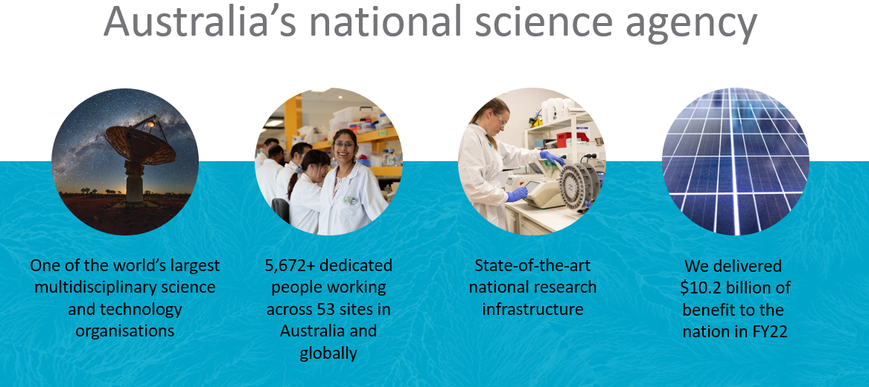
About CSIRO

CSIRO (Commonwealth Scientific and Industrial Research Organisation) is Australia’s national science agency and innovation catalyst and one of the world’s largest and most successful publicly funded research and development organisations.

CSIRO is one of the largest and most multidisciplinary mission-driven research agencies in the world.

With over 50 locations and over 5,000 people across Australia and internationally, CSIRO solves the greatest challenges through innovative science and technology to deliver world-class economic, environmental, and social benefits for Australia in a global context.

CSIRO are Australia’s most trusted research institution and most connected innovator, working with every Australian university, government and non-government agency and major Australian industry (including technology companies, the banking sector, small and medium businesses) and around the world, spanning research, government, industry to co-create commercialisation outcomes that deliver impact and create science driven technologies and economic value and a better future for all Australians.

Our collaborative research turns science into solutions for food security and quality, clean energy and resources, health and wellbeing, resilient and valuable environments, innovative industries, and a secure Australia and region.

CSIRO has also improved the lives of many around the world and some developments you will know well include Fast Wireless LAN (WiFi), the Hendra virus vaccine, polymer (plastic) banknotes, extended-wear contact lenses, Aerogard and the Total Wellbeing Diet to name a few.

To find out more, visit csiro.au.

CSIRO Strategy
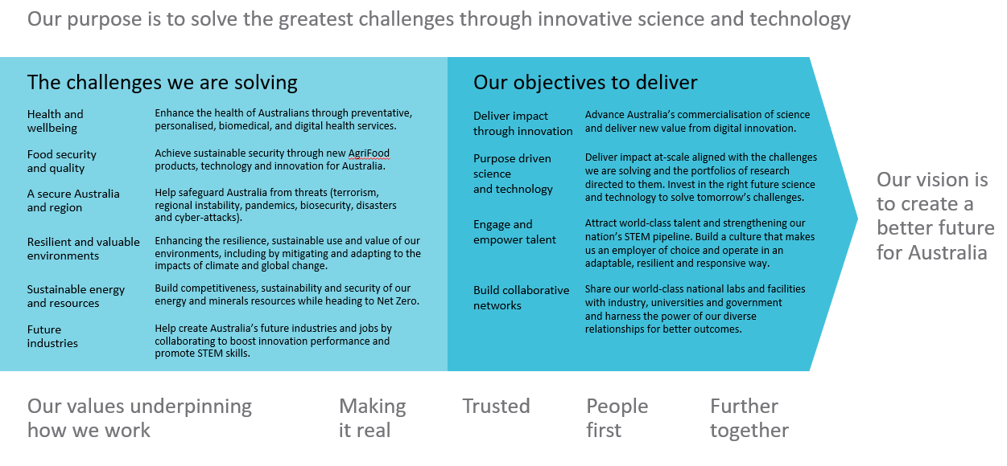

Leading @CSIRO Framework
The Leading @ CSIRO Framework (below) describes what is expected of all CSIRO leaders along with core capability areas and behaviours.

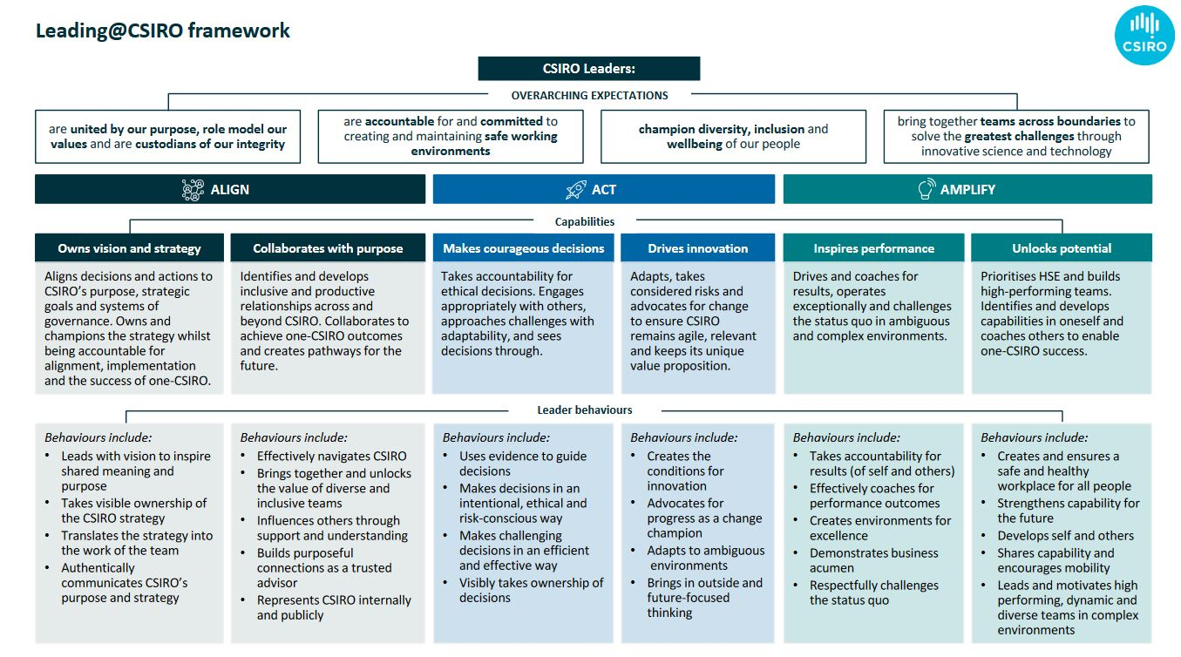

The ACDP National Facility
The Australian Centre for Disease Preparedness (ACDP), formally known as the Australian Animal Health Laboratory, is a critical part of national infrastructure and Australia’s highest level of biocontainment within a purpose-built biosecurity facility in Geelong – Victoria.
The ACDP provides the Australian Government and Industry groups with advice on exotic and emerging disease issues and in the general areas of biosecurity and counter-bioterrorism.
As Australia’s national animal health laboratory, ACDP conducts research in animal diseases and biosecurity to help protect Australia’s multi-billion-dollar livestock and aquaculture industries, and the general public, from emerging infectious animal and zoonotic disease threats and outbreaks. Its microbiologically and physically secure facilities allow teams to work safely with animal and zoonotic diseases while keeping them securely contained.

ACDP also operates as an international reference laboratory for specific diseases of concern to Australia and our region on behalf of the Australian Government, the World Organisation for Animal Health, and the United Nations’ Food and Agriculture Organization, and provides support and training to strengthen biosecurity across neighbouring countries. In this capacity, ACDP maintains laboratory equipment and skills to manage complex identification with rarely utilised tests, forming a key component of Australia's preparedness to deal with an infectious disease outbreak.

Scientific research at ACDP has also investigated some of the most dangerous infectious agents in the world and ACDP have played a pivotal role in response to a number of emerging diseases, including Hendra virus, Japanese encephalitis, avian influenza and COVID-19.

ACDP operates across two sites: a high containment facility in Geelong with laboratories at Physical Containment Levels 2, 3 and 4; and a Physical Containment Level 2 animal facility in Werribee, Victoria. The main site in Geelong has over 300 staff and affiliates, while the Werribee site has less than 10. These facilities are supported by highly specialised operations teams who maintain facility biocontainment, biosafety, quality assurance, training, site security and monitoring, engineering, and infrastructure maintenance.

Constructed in 1985 and operating ever since, ACDP is now undergoing a Part-Life Refit to future-proof and refresh the existing facility and infrastructure services. Pending final stage approvals, works are expected to commence this year and continue until 2027.

For further information about the ACDP, visit our website at Australian Centre for Disease Preparedness - CSIRO

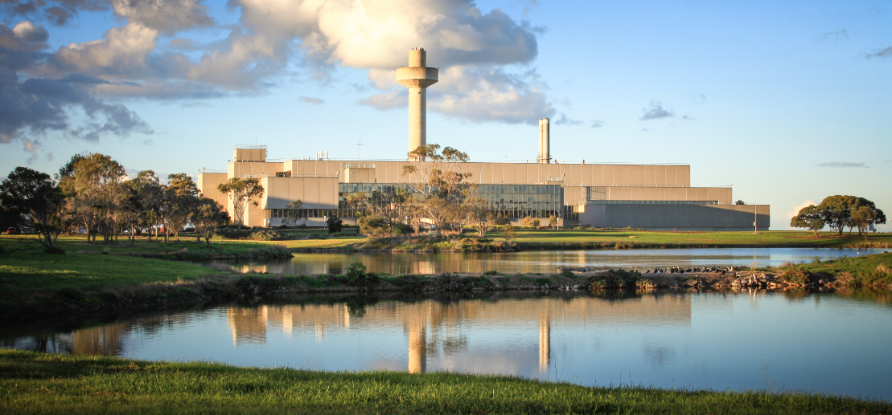

Southern view of the ACDP facility in Geelong, Victoria
Position Details
Job Title | Strategic Operations Director, ACDP
Job Reference | 91703
Tenure | Specified Term of 3 years – full-time
Salary Range | Salary range AUD $174k - $219k plus up to 15.4% super, based on experience and negotiable for the right candidate
Location | Geelong, Victoria (Australian Centre for Disease Preparedness)
Relocation Assistance | Will be provided to the successful candidate if required
Applications are open to | All Candidates who meet the requirements of the role (Visa sponsorship may be provided)
Position reports to the | ACDP/AHHL Business Unit Director (and is a member of the ACDP Leadership team)
Client Focus – Internal | 80%
Client Focus – External | 20%
Number of Director Reports | 3 – Operations Director; Bio Risk Manager; Animal Risk Manager  (with approximately 60 in the wider team)
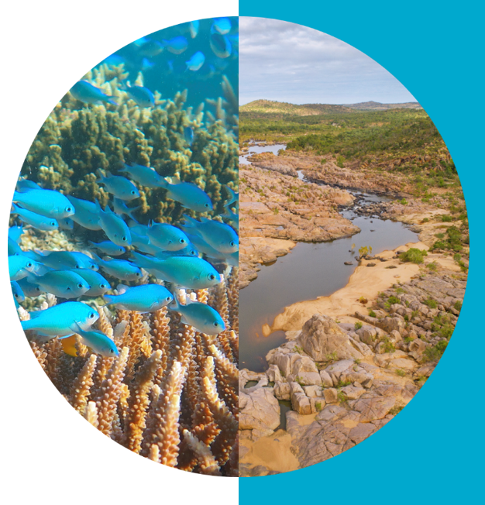

About the Role – Strategic Operations Director, ACDP
Summary

Reporting to the Business Unit (BU) Director ACDP, the Strategic Operations Director forms a key member of the ACDP leadership team and will be responsible for leading the formulation and implementation of the long-term strategy for the operation of the Facility, ensuring alignment to CSIROs goals and strategy.

The Strategic Operations Director at ACDP will lead the Facility Operations Program strategically to deliver outcomes and impact through effective and efficient operation and utilisation of the Facility. A key responsibility is to manage the risks inherent in the operation of the high containment facility ensuring the facility is maintained with alignment to legislative and regulatory compliance; risk mitigation, including zero-harm; high quality standards and best-practice governance.

This position is also responsible for identifying and integrating current and new opportunities for facility operations to better support science delivery.

Concurrently, the Director will effectively manage the Facility budget (while overseeing team and project budgets).

The ACDP facilities are supported by highly specialised operations teams who maintain facility biocontainment, biosafety, quality assurance, training, site security and monitoring, engineering, and infrastructure maintenance. The Director will oversee and provide empowering leadership and support to these operations teams via their three direct reports: Bio-risk Manager; Animal Risk Manager and Facility Operations Manager (which includes health and safety and quality assurance) ensuring a high-performance and collaborative culture and the continuation of high-quality outcomes are maintained at the Facility.

The ACDP facilities can also be utilised by third parties so another element of this role will be to promote and position the scientific services and national benefits of ACDP; to enhance and maintain collaborations with key stakeholders while also identifying and maintaining relationships with pivotal national infrastructure funders, including but not limited to the National Collaborative Research Infrastructure Strategy (NCRIS). The ability to build strategic and collaborative alliances broadly within CSIRO will also be key.

ACDP played a crucial role in Australia’s COVID-19 emergency response. This experience highlighted opportunities for CSIRO to explore the potential role and scope of ACDP in Australia’s future, leveraging One Health capabilities across ACDP, manufacturing, digital, agriculture and health.
Refurbishment plans are currently underway at ACDP, so the successful candidate will also have the opportunity to contribute to and input into the facility refurbishment plans, thus contributing to the future of this national facility.

Duties and Key Result Areas
Facility Leadership & Operations
- Lead delivery of the ACDP Facility Operations Program, including prioritisation, direction setting, efficient and effective utilisation of facility resources and access by third parties.
- Manage legislative and regulatory compliance risks required for the National Facility.
- Maintain compliance with quality assurance standards and ensure an ethos of continual improvement.
- Ensure all potential microbiological safety, HSE and ethics incidents are promptly and effectively responded to, managed, investigated, reported and remediated
- Assist the Business Unit Director with planning and implementation of policies.
- Maintain a science ready facility to serve the wider research community.
- Develop and maintain a comprehensive strategic overview of the risk profile and opportunities of the facility, managing identified risks and opportunities.
- Oversee the practice and adherence to ethical codes of working with animals.

Capability Leadership
- Strive for "Zero Harm" (physical and psychological) through a commitment to a healthy, safe and environmentally sustainable workplace.
- Attract, develop and retain world class talent which will meet current and future needs.
- Model appropriate and professional behaviour in the workplace and manage people matters proactively.
- Effectively lead change initiatives across the ACDP and CSIRO.
- Manage senior staff who are often experts in their own field and be responsible for fostering an environment in which staff can achieve their full potential aligning their career aspirations with the Organisation’s needs.

Engagement and Partnerships
- In collaboration with the Business Unit Director, lead the formulation and implementation of long-term strategy for the operation of the Facility.
- Maintain and extend relationships with pivotal national infrastructure funders, including but not limited to the National Collaborative Research Infrastructure Strategy (NCRIS) and engagement with the ACDP part-life refit project.
- Deliver trusted advice concerning National Facility operations to key clients nationally and internationally.
- Develop and implement a comprehensive communications strategy and a stakeholder relationship plan to promote and position the scientific services provided by the National Facility in line with the ACDP vision.
- Build strategic alliances within the organisation to collaboratively execute CSIRO strategy across lines of business.

Resource Leadership
- Ensure best practice governance for utilisation of facility resources.
- Ensure effective use of physical infrastructure and resources in an environmentally sustainable way, in line with our ISO14001 accreditation.
- Effectively manage the budget for animal studies, operations and bio risk management teams. Track individual project budgets and plan team staffing/utilisation.

Other Duties
- Communicate openly, effectively and respectfully with all staff, clients and suppliers in the interests of good business practice, collaboration and enhancement of CSIRO’s reputation.
- Work collaboratively as part of a multi-disciplinary, regionally dispersed team to carry out tasks in support of CSIRO’s scientific objectives.
- Adhere to the spirit and practice of CSIRO’s Values, Code of Conduct, Health, Safety and Environment procedures and policy, Diversity initiatives and Zero Harm goals.
- Other duties as directed.

About You
To be considered for this exciting leadership role within ACDP at CSIRO, we are seeking a Strategic Operations Director who has experience managing a similar sized large complex facility and experience ensuring that the required alignment to legislative and regulatory compliance; risk mitigation, including zero-harm; high quality standards and best-practice governance are maintained.

You are an engaging leader who demonstrates strong interpersonal and communication skills with a proven ability to form and maintain credible, respectful and collaborative relationships with both internal and external stakeholders. At times you may also need to draw upon your strong influencing skills.

You bring strong people leadership capabilities with the ability to empower and facilitate positive and collaborative team relationships with the ability to anticipate and resolving complex technical, management and administrative issues respectfully.

Experience establishing a strategy and operationalising this with a visionary approach while confidently contributing to policy directions is a must. Your strong business acumen; results-oriented approach and formidable financial skills will be utilised as will your proven track record in project management and leading “best practice” change via a collaborative approach that brings your key stakeholders and your team on the journey.

In addition to the above, a degree qualification or experience in either biorisk management, quality assurance, laboratory animal management or workplace health & safety would be held in high regard but is not mandatory. However, demonstrated experience and achievement in a senior leadership role in animal or public health, biological sciences or related area, ideally with postgraduate managerial qualifications is expected.

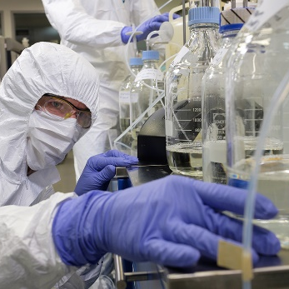

Selection Criteria

Essential
Under CSIRO policy only those who meet all essential criteria can be appointed.
- A degree (or equivalent experience), in conjunction with demonstrated achievement in senior advisory and directorial roles in animal or public health, biological sciences or related area, ideally with postgraduate directorial qualifications.
- Demonstrated experience and understanding of risk management, incident response, policies and procedures, and external regulations relevant to the ACDP Facility, or similar facilities internationally.
- Demonstrated strong planning, financial, project management, and change management skills, and experience at the level of a national program of comparable size and scale to the ACDP Facility.
- Demonstrated ability to effectively build strong relationships with staff, external stakeholders and clients at all levels and across boundaries, together with superior interpersonal, negotiation and influencing skills.
- The ability to work effectively in a team environment, collaborate widely both internally and externally, and provide guidance to directors and staff.
- A record of strong leadership that has contributed to or defined policy direction, strategy and prioritisation of activities across a complex facility.
- A history of anticipating and successfully resolving complex technical, management and administrative issues, which have potential for impact at a strategic level.
- A history of professional and respectful behaviours and attitudes in a collaborative environment.

Desirable
- Qualifications or experience in either biorisk management, quality assurance, laboratory animal management or workplace health & safety.

Required Competencies
- Teamwork and Collaboration: Creates and fosters an environment in which there is a high level of cooperation within and between teams. Facilitates positive team relationships to build interactions across Business Units and the organisation.
- Influence and Communication: Uses complex influencing strategies, for example, assembling strategic coalitions, building behind the scenes support and the tactical use of information to gain support.
- Resource Management / Leadership: Contributes to or defines Business Unit / organisational policy directions, strategic planning and operationalises the vision for staff and gains commitment to the direction chosen. Plans, seeks, allocates resources and monitors to achieve outcomes. Adopts a mentor role.
- Judgment and Problem Solving: Resolves major conceptual scientific, technical, commercial or management problems, which have a significant impact upon the field of research, professional function, the Business Unit or the Organisation. Situations faced have little or no precedent and require original concepts and approaches.
- Independence: Commits significant resources in the face of uncertainty and takes calculated risks to improve performance and achieve challenging goals. Uses personal energy to drive change strategies. Formulates and implements contingency plans to minimise the impact of potential risks. Accepts personal responsibility for the outcomes of decisions/risks taken.
- Adaptability: Is flexible in response to external change or when faced with external constraints. Identifies and promotes the opportunities arising as a result of change.

Special Requirements

Security Assessment and Microbiological Security Requirements for Personnel Working on the Australian Centre for Disease Preparedness (ACDP) Site:
To be eligible for this position you must be willing and able to comply with the following:
- Certain positions including those working at the ACDP microbiological secure area will require security clearance at a level appropriate to the duties of the position. Confirmation of the appointment is subject to obtaining that clearance.
- It is essential that all work on exotic or emerging diseases carried out at ACDP is conducted in a safe manner to prevent the escape of the disease agents used, and to this end, all activities and personnel will be subject to appropriate microbiological security measures. Consequently, while working at ACDP, you may not reside on a property on which are kept any of the following animals: sheep, cattle, pigs, goats, horses, asses, mules and camelids, any other cloven-hoofed animal, fowls, turkeys, geese, domestic ducks, caged birds, emus or ostriches. Personnel working with diseases of aquatic animals may not keep aquarium fish at their place of residence and at times specific species may be excluded depending on the nature of the work conducted.
- In addition, for a period of seven days after working in the microbiologically secure area of ACDP, personnel may not have close contact with any of the above animals, amphibians or birds or the actual places where these animals are held, or visit any aquatic animal farm or aquatic animal hatchery.
- Working in the barrier maintained Small Animal Facility or the Werribee Animal Health Farm requires avoidance of additional animals such as mice, rats, guinea pigs, rabbits, ferrets and poultry of a minimum of 3 days prior to arrival.
- Certain positions will require medical assessment and vaccinations against various agents which may include (where applicable) influenza, Hepatitis b, Rabies, Japanese encephalitis, Q Fever and SARS-CoV-2 or other agents if working with certain viruses. The successful candidate will be required to provide satisfactory evidence of vaccination against certain viruses / diseases prior to commencement and/or may be expected to be vaccinated against other viruses/diseases during the course of their employment.
- Positions working at PC4 will also require a pre-employment psychological assessment.
- Given ACDP’s role in the International Regional Program, there may be a requirement for some personnel to travel internationally and if required for this work, suitable staff should be able to obtain a valid passport and obtain applicable vaccination.
- In the event of an emergency disease response, ACDP may be required to implement the Emergency Animal Disease Response Plan and personnel may be directed to work in areas other than their usual assignment in order to meet the needs of the response. This direction may include work outside usual working hours, and may require working onsite.
- Personnel must abide by Occupational Health, Safety and Environment regulations. Safety signs and directives issued by CSIRO personnel must be complied with at all times.
- Access restrictions apply to the Werribee Animal Health Facility (WAHF) site that is associated with, but remote from, the ACDP site.

The successful candidate will be required to:
- Obtain and provide evidence of a National Police Clearance or equivalent. Please note that individuals with criminal records are not automatically deemed ineligible. Each application will be considered on its merits.
- Undertake a National Health Security Check (to be arranged post-commencement).
- Obtain and maintain a AGSVA security clearance at the Negative Vetting Level 1 (to be arranged post-commencement). As this is a designated security assessed position and, the successful candidate will need to meet certain requirements to continue in the role, including but not limited to having at least 10 years of checkable background?
- Travel interstate and, if required, internationally.
- If the successful candidate is not an Australian Citizen or Permanent Resident, they may be required to undergo additional security clearances, which may include medical examinations and an international standardised test of English language proficiency (i.e. IELTS test- https://ielts.com.au/).

Flexible Working Arrangements
We work flexibly at CSIRO, offering a range of options for how, when and where you work. Talk to us about how this role could be flexible for you. Work life balance.

Diversity and Inclusion
We are working hard to recruit diverse people and ensure that all our people feel supported to do their best work and feel empowered to let their ideas flourish.
We are committed to the safety and wellbeing of all children and young people.

To Apply
As part of their application process we ask that candidates provide the following:
- Curriculum Vitae – outlining relevant aligning experience.
- Cover Letter – outlining the motivation and a high level snapshot of relevant capabilities and experience. This document should not be longer than two pages.
- Contact details for three Referees – Referees will only be contacted after prior consultation with the candidate. It is the candidate's responsibility to ensure that their referees are willing to provide reports when contacted by CSIRO.

CSIRO is a values-based organisation. In your application and at interview you will need to demonstrate behaviours aligned to our values of:
  - People First
  - Further Together
  - Making it Real
  - Trusted

For any questions not answered in the above, please feel free to contact:
Melanie Pecanek
Executive Talent Acquisition Business Partner
0487 373 780
Melanie.pecanek@csiro.au

Applications close 11:59pm AEST, 4th June 2023
As Australia’s national science agency and innovation catalyst, CSIRO is solving the greatest challenges through innovative science and technology.
CSIRO. Unlocking a better future for everyone.
Contact us
1300 363 400
+61 3 9545 2176
csiro.au/contact
csiro.au

