Position Details

CSIRO Early Research Career (CERC) Postdoctoral Fellowship– CSOF4
The following information is for applicants
Advertised Job Title | CSIRO Winanga-y Postdoctoral Fellowship in GHG Emissions of Crop-livestock Systems
Job Reference | 95071
Tenure | Specified Term of 3 years  Full-time or Part-time equivalent
Salary Range | AU$92,624 to AU$101,459 pa (pro-rata for part-time)  plus up to 15.4% superannuation
Location(s) | Brisbane/Toowoomba, Queensland
Relocation Assistance | Will be provided to the successful candidate if required
Applications are open to | All Candidates
Position reports to the | Principal Research Scientist
Client Focus – Internal | 100%
Client Focus – External | 0%
Number of Direct Reports | 0
Enquire about this job | Lindsay Bell via email at lindsay.bell@csiro.au or phone +61 7 4571 3201
How to apply | Apply online at https://jobs.csiro.au/  Internal applicants please apply via Jobs Central  If you experience difficulties when applying, please email careers.online@csiro.au or call 1300 984 220.
Acknowledgement of Country

CSIRO acknowledges the Traditional Owners of the land, sea and waters, of the areas that we live and work on across Australia. We acknowledge their continuing connection to their culture and pay our respects to their Elders past and present. View our vision towards reconciliation.
Child Safety
CSIRO is committed to the safety and wellbeing of all children and young people involved in our activities and programs. View our Child Safe Policy.

Role Overview
CSIRO Early Research Career (CERC) Fellowships provide opportunities to scientists and engineers who have completed their doctorate and have less than three years relevant research experience. These Fellowships aim to develop the next generation of future leaders of the innovation system through:
- A differentiated career development program to deliver capability excellence and breadth across all facets of the national innovation system;
- Research training via strategic research and development projects with a clear focus that will deliver real impact through science and engineering excellence;
- An innovative culture supporting the development and demonstration of original thinking and expertise leading to peer-recognition; and
- Opportunities to develop skills and experience in collaborative research teams to effectively work within national and global multi/transdisciplinary and multi-stakeholder environments.
CERC Fellows are appointed for three years or part time equivalent.
We are thrilled to be able to deliver on the commitment we made in our strategy to invest in frontier science with the new CSIRO Agriculture & Food Winanga-y Postdoctoral Fellowship scheme. The word Winanga-y (pronounced win-na-gnay) is a cultural asset gifted by the Gomeroi Nation in Myall Vale to CSIRO's Agriculture and Food Business Unit to name the Postdoctoral Fellowship Scheme. Winanga-y means to understand, know, remember, and think.
This CERC Fellow has the opportunity to develop their skills, reputation and build a national network with researchers investigating ways to improve the environmental credentials and GHG footprint of broadacre farming systems.
The focus of this CERC Fellowship role is to better understand the implications for farm greenhouse gas emissions of the integration of crop and livestock production across Australia’s broadacre farming regions. The farming sector can play an important role in mitigating climate change through both reducing GHG emissions and, perhaps more importantly sequestering carbon from the atmosphere. Livestock production contributes to the latter via practices like using pasture phases to build soil C. However, there are also emissions from grazing animals that need to be considered in the whole farm GHG balance. The CERC Fellow will apply systems modelling and methodologies to compute the GHG emissions and soil C sequestration from both cropping systems and grazed pastures, under different management and climate scenarios. Importantly, the work will expand previous limited case studies to broader scales, potentially nationally. The objective of this work is to understand the implications of crop and livestock integration across Australia’s broadacre farming regions and under what circumstances are the greatest GHG mitigation and food production intensity can be provided.

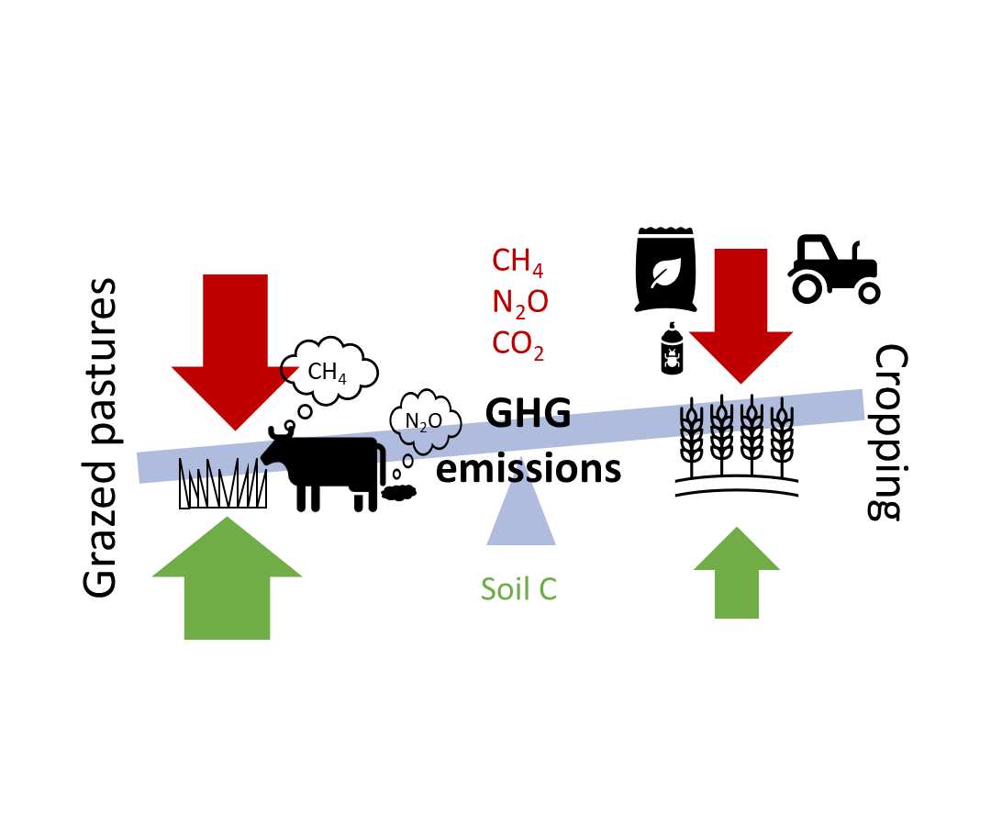
The CERC Fellow will bring together biophysical simulation modelling with life-cycle accounting methods to compute GHG emissions from the different crop and livestock production systems. A major challenge will be to bring together spatial information, coupled with crop-livestock systems models and GHG accounting methodologies to compute whole-farm-system GHG emissions that are integrated across system boundaries.
The CERC Fellow will work across the Systems and Sustainability Programs within CSIRO’s Agriculture and Food Business Unit. They would preferably be based in south-east Queensland (either Brisbane or Toowoomba) with leading researchers in this field.

Duties and Key Result Areas
Under the direction of senior research scientists and engineers, this CERC Fellow will:
  - Integrate spatial soil, climate, and land use data with whole-farm enterprise information to conduct complex simulation modelling of crop-livestock systems.
- Produce high quality scientific papers suitable for publication in high quality international journals and conferences.
- Work effectively as part of a multi-disciplinary research team, to undertake independent scientific investigations and carry out associated tasks under the guidance of more senior Research Scientists/Engineers.
  - Recognise and exploit opportunities for innovation and the generation of new theoretical perspectives, and progress opportunities for the further development or creation of new lines of research.
  - Communicate research findings to diverse audiences including farmers, advisors, industry bodies and policy makers.
  - Carry out research investigations requiring originality, creativity and innovation.
  - Record, manage, and analyse data/information using relevant domain data science techniques.
  - Proactively undertake development to grow effective researcher capabilities to support career goals.
  - Adhere to the spirit and practice of CSIRO’s Values, Code of Conduct, Health, Safety and Environment procedures and policy and diversity initiatives.
- Other duties as directed.

The CERC Fellow learning, development and training program is developed between the CERC Fellow and their CSIRO supervisor. The program will focus on enhancing the Fellow’s capabilities to the level expected of an independent researcher and will include on-the-job and course-based development encompassing:
- Discipline-specific techniques and protocols
- Professional growth
- Project management
- Communication and influencing skills
- Working and collaborating with others

Selection Criteria

Essential
Under CSIRO policy only those who meet all essential criteria can be appointed.
- A doctorate (or will shortly satisfy the requirements of a PhD). The doctorate must be in a relevant discipline area, such as agricultural or environmental science or related disciplines.
Please note: To be eligible for this role you must have no more than 3 years (or full-time equivalent) of relevant research experience.
- Demonstrated ability to conceive and undertake original, creative and innovative research by generating and pursuing novel ideas and solutions to scientific research problems.
- A demonstrated publication history of authorship on scientific papers in peer reviewed journals and/or reports, grant applications or inventorship on patent applications.
- A proven ability to work effectively as part of a multi-disciplinary team, plus the motivation and discipline to carry out autonomous activities.
- High level written and oral communication skills with the ability to represent the research team effectively internally and externally, including the presentation of research outcomes at national and international conferences.
- A record of science innovation and creativity, including the ability & willingness to incorporate novel ideas and approaches into scientific investigations.

Desirable
- Experience and/or demonstrated knowledge of the innovative application and/or development of crop and/or livestock systems simulation models (e.g. APSIM, GrazzGro/EcoMod).
- Demonstrated knowledge and application of contemporary data management approaches, including spatial data analysis and analysis of large data sets.
- Understanding or experience with GHG accounting methodologies and approaches.
- Understanding of soil C and N cycling in agricultural systems.
- Possession of an Australian C class (motor vehicle) licence or ability to obtain one.

Required Competencies
- Teamwork and Collaboration: Cooperates with others to achieve organisational objectives and may share team resources in order to do this. Collaborates with other teams as well as industry colleagues.
- Influence and Communication: Uses knowledge of other party's priorities and adapts presentations or discussions to appeal to the interests and level of the audience. Anticipates and prepares for others reactions.
- Resource Management/Leadership: Allocates activities, directs tasks and manages resources to meet objectives. Provides coaching and on the job training, recognises and supports staff achievements and fosters open communication in the team.
- Judgement and Problem Solving: Investigates underlying issues of complex and ill-defined problems and develops appropriate response by adapting/creating and testing alternative solutions.
- Independence: Recognise and makes immediate changes to improve performance (faster, better, lower cost, more efficiently, better quality, improved client satisfaction).
- Adaptability: Copes with ambiguity or situations that lack clarity. Adapts readily to changing circumstances and new responsibilities (which may include activities outside own preferences) in the interests of achieving team objectives. Recognises the need for and undertakes personal development as a result of changes.

To be appointed as a CERC Fellow within CSIRO, candidates are required to have submitted their doctoral thesis at the time of commencement, as a minimum requirement, if PhD conferment has not been obtained. If a candidate has submitted, but their PhD has not yet been formally attained, the starting salary will be CSOF4-1 ($89,680). Upon CSIRO receiving written confirmation that the PhD has been awarded (within a six month period from commencement date), the salary will be increased to the negotiated level and the difference will be back-paid to the Officer’s start date.
Special Requirements
Appointment to this role is subject to provision of a pre-employment background check and may be subject to other security/medical/character clearance requirements.

- The successful candidate will undertake a pre-employment background check. Please note that individuals with criminal records are not automatically deemed ineligible. Each application will be considered on its merits.
- If the successful candidate is not an Australian Citizen or Permanent Resident, they may be required to undergo additional security clearances, which may include medical examinations and an international standardised test of English language proficiency (i.e. IELTS test https://ielts.com.au/).

Our value proposition

We want CERC Fellows to join our world class science, engineering and digital teams to solve big, complex problems that make a real difference to the future of Australia and the world.
You'll get to work with some of the most talented minds in their fields, not just in Australia, but in the world. At CSIRO, we spark off each other, learn from each other, trust each other and collaborate closely to achieve more than we could individually.
Find out more about our CSIRO Early Research Career (CERC) Fellow Experience Employee Value Proposition (EVP) here.

About CSIRO
We solve the greatest challenges through innovative science and technology. Visit CSIRO Online and CSIRO Agriculture and Food for more information.
CSIRO is a values-based organisation. In your application and at interview you will need to demonstrate behaviours aligned to our values of:
- People First
- Further Together
- Making it Real
- Trusted

