

Australia’s National  
Science Agency

Information for applicants

**Acknowledgement of Country**

In the spirit of reconciliation, CSIRO acknowledges the Traditional Custodians of country throughout Australia and their connections to land, sea and community. We pay our respect to their Elders past and present and extend that respect to all Aboriginal and Torres Strait Islander peoples today. View our [vision towards reconciliation](https://www.csiro.au/en/about/Indigenous-engagement/Reconciliation-Action-Plan)

**Child Safety**

CSIRO is committed to the safety and wellbeing of all children and young people involved in our activities and programs. View our [Child Safe Policy](https://www.csiro.au/en/about/policies/child-safe-policy).

Deputy Director, Health and Biosecurity

About CSIRO

*The Commonwealth Scientific and Industrial Research Organisation (CSIRO), is Australia's premier research body and National Science Agency. We solve the greatest challenges through innovative science and technology to build prosperity, growth, health, and sustainability for our customers, all Australians, and the world.* [***csiro.au***](https://www.csiro.au/)***.***

CSIRO is one of the world’s largest and most successful publicly funded research and development organisations and also one of the most multidisciplinary mission-driven research agencies in the world, with 6,316 people, and 49 sites throughout Australia and 2 globally.

CSIRO solves the greatest challenges through innovative science and technology, and we are committed to complementing our world-class science capabilities with outcome-focussed research to generate and deliver economic, environmental, and social benefits for Australia in a global context.

CSIRO is also Australia’s most trusted research institution and most connected innovator, working with most Australian universities, government and non-government agencies and major Australian industries to co-create commercialisation outcomes that deliver impact and create science-driven technologies and economic value and a better future for all Australians.

Our collaborative research turns science into solutions for food security and quality, clean energy and resources, health and wellbeing, resilient and valuable environments, innovative industries, and a secure Australia and region, securing our future national prosperity as well as environmental and social benefits.

CSIRO acknowledges the extraordinary contributions Aboriginal and Torres Strait Islander people have made, and continue to make, to our culture, the economy and science. We’re working with Indigenous communities and organisations to create Indigenous-driven science solutions that support sustainable futures for Indigenous peoples, cultures, and Country.

CSIRO Strategy & Values

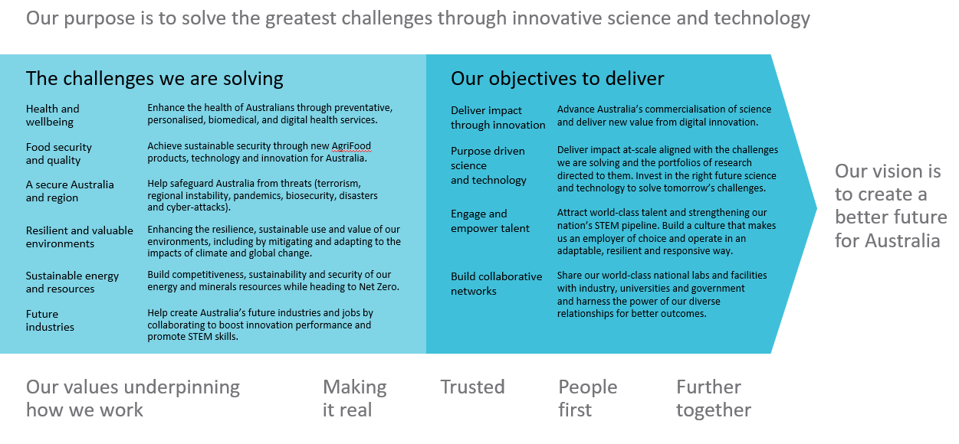

*CSIRO's values are more than just words. They represent what is unique and special about CSIRO and underpin not just the work we do, but how we do it, and how we interact with our colleagues and the diverse range of partners we collaborate with every day.* [*CSIRO’s values - CSIRO*](https://www.csiro.au/en/about/Values)

Leading@CSIRO Framework

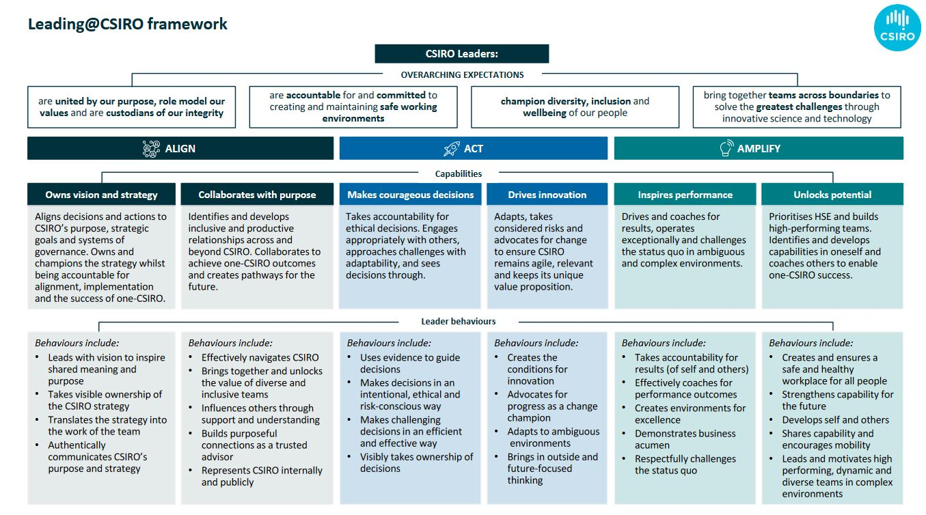The Leading@CSIRO Framework (below) outlines what is expected of all CSIRO leaders.

About CSIRO Health and Biosecurity

*We're dedicated to conducting scientific research that develops products and services to address the complexity and interdependencies of human, animal and environmental health and biosecurity challenges to provide benefits to Australia and the world.* [**Health and Biosecurity Business Unit - CSIRO**](https://www.csiro.au/en/about/people/business-units/health-and-biosecurity)

The Health and Biosecurity (H&B) business unit is one of nine impact science business units in CSIRO. As of November 2023, the H&B team employs approximately 400 staff and 120 affiliates. H&B’s staff and affiliates work across Australia, with primary sites in Geelong, Canberra, Brisbane, Adelaide, and Sydney.

The business unit undertakes world class multidisciplinary science, dedicated to conducting research and development that addresses the complexity and interdependencies of human, animal and environmental health and biosecurity challenges across Australia and the world, improving prevention, detection and responses to health and biosecurity threats.

Enhancing the health and wellbeing of all Australians is one of the six national challenges that CSIRO is assisting the nation to overcome. This challenge is only becoming more urgent as Australia’s health and biosecurity sectors come under increasing pressure. Emerging infectious diseases are a persistent risk that require ongoing attention. Additionally, as Australia’s population ages and the chronic disease burden increases, we need more efficient and effective ways of delivering healthcare.

From a biosecurity perspective, weeds, pests, and diseases threaten Australia’s agricultural industries and natural ecosystems at increasing rates. There is a pressing need to consider new ways of preventing the entry these threats into Australia, as well as limiting the spread and damage caused by outbreaks.

There is also an increasing requirement to address these challenges through digital technologies and a whole-of-system One Health approach underpinned by human, animal and environmental health science and technology.

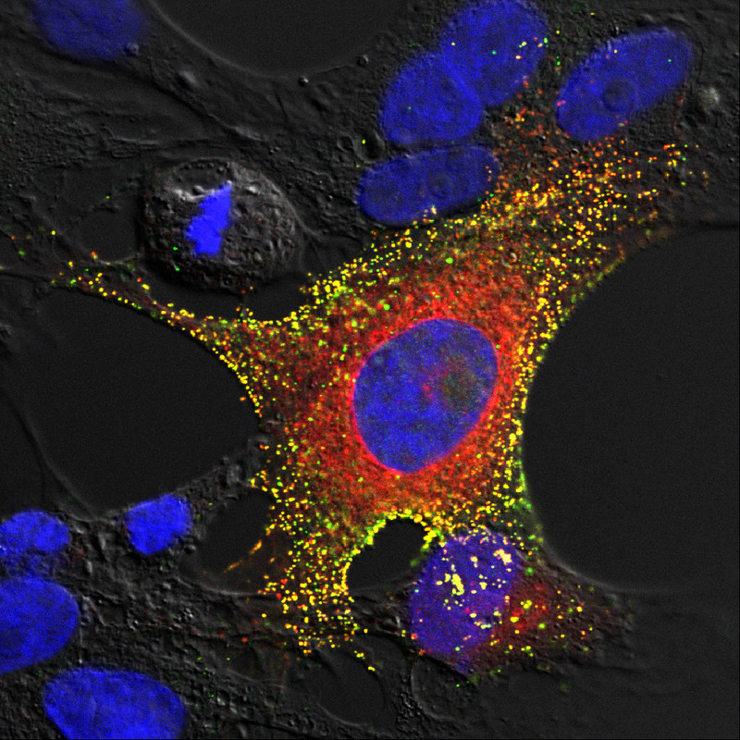

The H&B business unit focusses research and development around building Australia’s resilience to:

* health and biosecurity threats and megashocks;
* accelerating technological and digital transformation of healthcare and biosecurity systems;
* improving health and wellbeing of all Australians.

Working at the interface of research, industry, and government, H&B’s capability strengths include digital health interoperability, virtual care, application of artificial intelligence and machine learning platforms, classic and advanced solutions to biosecurity, and zoonotic and vector borne disease research and surveillance. The H&B Business Unit works with a diverse range of people and partners that span Australia and multiple countries, fostering a shared vision to create measurable economic, environmental, and social impact.

Learn more about [CSIRO Health and Biosecurity](https://www.csiro.au/en/about/people/business-units/health-and-biosecurity)

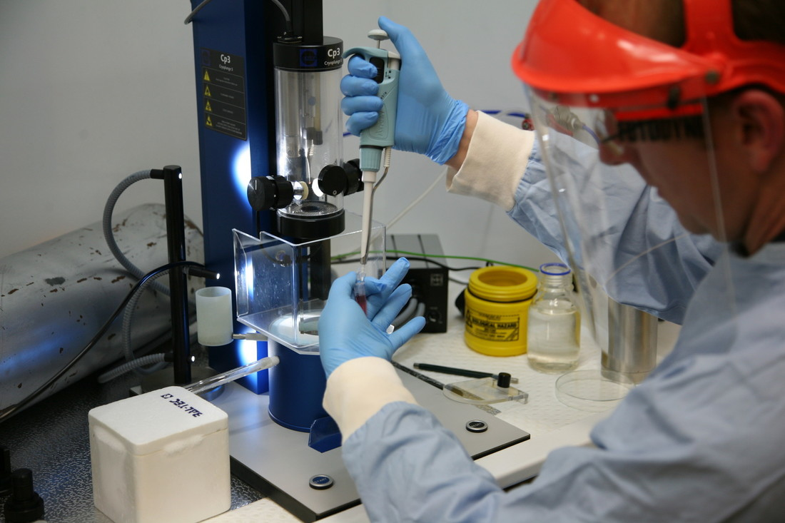

About the Role: Deputy Director, Health and Biosecurity

Position Details

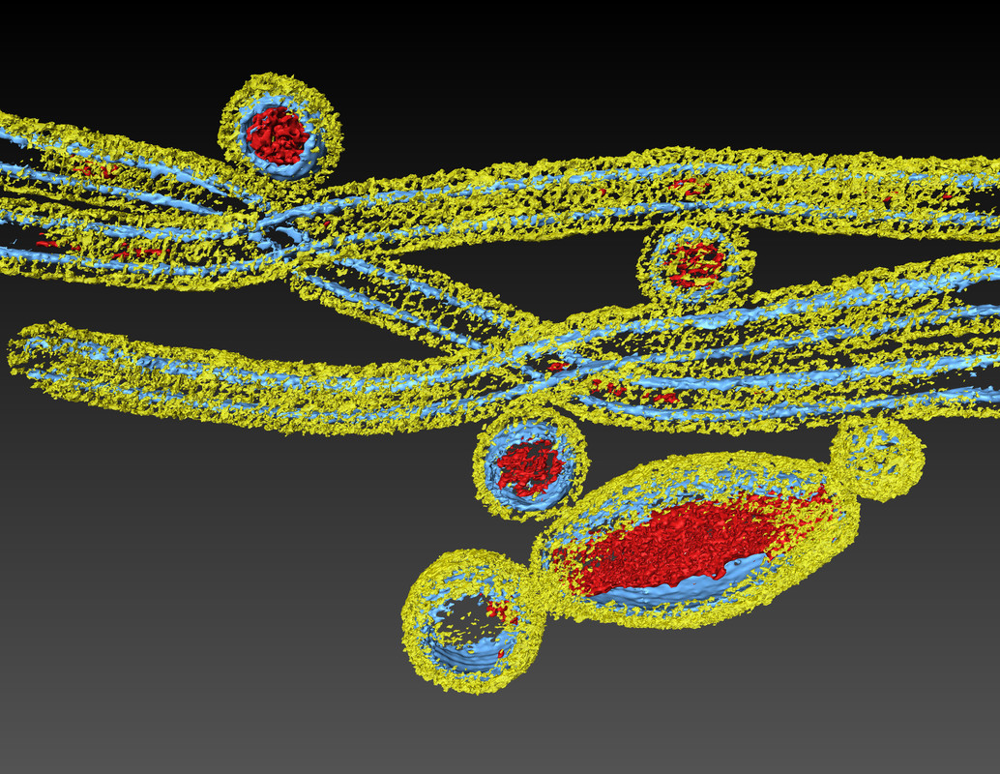

|  |  |
| --- | --- |
| Tenure | Specified Term – 3 years, Full-time |
| Salary Range | Attractive salary package negotiable for the right candidate + up to 15.4% superannuation. |
| Location | Ideally Canberra or Melbourne, however other Australian capital city CSIRO sites may be considered.  (With the flexibility to balance time between home / office and with a willingness and ability to travel interstate and, if required, internationally). |
| Relocation Assistance | Will be provided to the successful candidate if required. |
| Applications are open to | Australian / New Zealand Citizens and Australian Permanent Residents only. |
| Position reports to the | Director Health and Biosecurity |
| Client Focus – Internal | 50% |
| Client Focus – External | 50% |
| Size of Business Unit | 400 staff and 120 affiliates |

Role Overview

The Deputy Director will work closely with the Health & Biosecurity (H&B) Director, playing a leading role in the provision of scientific vision, leadership, and direction of the Business Unit to ensure CSIRO is scientifically impactful and competitive. The Deputy Director is a member of the Business Unit Leadership Team and the CSIRO Science Council and will deputise for the Business Unit Director as required. The Deputy Director will oversee delivery of H&B’s Future Science Platforms (FSPs) and Missions and engage in other Business Unit FSPs and Missions, as required.

The Deputy Director will lead the development, implementation and monitoring of strategic capability plans for people and scientific infrastructure in line with H&B and CSIRO’s objectives. This will require working with the H&B Leadership Team to outline requirements, and collaboration with CSIRO’s other Deputy Directors to ensure appropriate capability is maintained and developed for CSIRO to effectively execute its strategy. The Deputy Director will be responsible for working with H&B’s Research Directors to ensure there is a diverse pipeline of scientific talent to meet existing and emerging CSIRO priorities, and will lead the rewards and promotions process for H&B.

The Deputy Director will collect and apply internal and external intelligence to ensure H&B’s project portfolio drives scientific excellence and leads to impact in line with CSIRO’s research objectives. The role will bring research expertise to drive more focused, impactful work whilst ensuring a portfolio of immediate, medium, and long-term impact. The Deputy Director will lead activities focused on monitoring, evaluating, and improving the impact of H&B’s portfolio. This role is expected to be active in project scoping and delivery, ranging from early-stage research to commercialisation activities driven by H&B and our partner Business Units.

The role will work closely with the H&B Leadership Team and broader CSIRO leadership regarding management of strategic relationships and alliances with the Business Unit’s partners, both domestic and international, to ensure optimal competitive positioning, organisational alignment, and delivery in the national interest.

To be considered for this exciting leadership role, you will be an engaging leader with a deep knowledge of the research and development sector. You will have exceptional interpersonal, influencing and communication skills combined with a proven ability to form and maintain relationships with executive stakeholders.

Experience in strategic portfolio development and delivery with a visionary approach is a must. You bring demonstrated people leadership capabilities with the ability to empower and facilitate positive and collaborative team relationships and the foresight to anticipate and efficiently resolve complex technical, management and administrative issues.

This position would suit a highly motivated, outcome orientated leader with exemplary values who can inspire others and create a collaborative and innovative culture where our people thrive.

Duties and Key Result Areas

**Science & Impact Leadership**

* Provide high level strategic leadership to ensure the H&B Business Unit remains globally scientifically competitive.
* Develop and promote a culture of science excellence by focusing on the translation of new ideas through to national and international impact.
* Drive effective development, utilisation, and delivery of Business Unit science capability in accordance with research and investment priorities.
* Contribute as an active member of CSIRO Science Council, providing recommendations to the CSIRO Research Office on mechanisms to secure future science investment.

**Functional Leadership**

* Contribute to strategic and operational planning for the Business Unit, and leadership in the implementation, monitoring, and evaluation of these plans.
* Develop and lead major proposals aligned with future science direction and be accountable for their implementation, performance, and outcomes.

**Capability & Resource Leadership**

* Strive for “Zero Harm” (physical and psychological) through a commitment to a healthy, safe and environmentally sustainable workplace.
* Shape science capability internally and externally through partnerships and collaborations to meet future science opportunities, program goals and impact pathways.
* Support H&B Leadership Team in world class talent management, including succession planning and in prioritisation and deployment of investments.
* Monitor long-term economic and science trends to forecast capability demand and identify medium and long-term plans for scientific infrastructure.

**Engagement & Partnership**

* Develop and manage priority external relationships to advance CSIRO’s interests, improve science delivery, and to achieve H&B’s strategic goals.
* Provide high-level scientific representation and advice associated with CSIRO’s cross Business Unit capability, nationally and internationally.
* Create opportunities for cross-Business Unit collaboration on significant national science initiatives and projects, across government, industry, and university sectors.

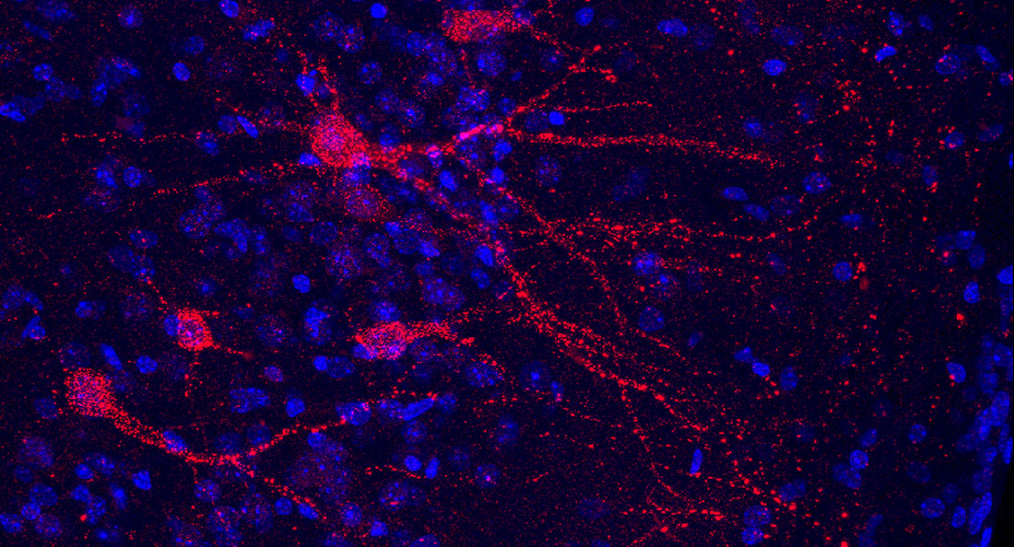

Required Competencies

* **Teamwork and Collaboration:** Creates and fosters an environment in which there is a high level of cooperation within and between teams. Facilitates positive team relationships to build interactions across Business Units and the organisation.
* **Influence and Communication:** Uses complex influencing strategies, for example, assembling strategic coalitions, building behind the scenes support and the tactical use of information to gain support.
* **Resource Management/Leadership:** Contributes to or defines Business Unit / organisational policy directions, strategic planning and operationalises the vision for staff and gains commitment to the direction chosen. Plans, seeks, allocates resources and monitors to achieve outcomes. Adopts a mentor role.
* **Judgement and Problem Solving:** Resolves major conceptual scientific, technical, commercial or management problems, which have a significant impact upon the field of research, professional function, the Business Unit or the Organisation. Situations faced have little or no precedent and require original concepts and approaches.
* **Independence:** Commits significant resources in the face of uncertainty and takes calculated risks to improve performance and achieve challenging goals. Uses personal energy to drive change strategies. Formulates and implements contingency plans to minimise the impact of potential risks. Accepts personal responsibility for the outcomes of decisions/risks taken.
* **Adaptability:**Is flexible in response to external change or when faced with external constraints. Identifies and promotes the opportunities arising as a result of change.

Selection Criteria

#### Essential

*Under CSIRO policy only those who meet all essential criteria can be appointed.*

1. A degree in conjunction with demonstrated achievement in senior leadership roles within the health and biosecurity sectors, ideally with postgraduate qualifications.
2. Demonstrated experience working within or across multidisciplinary organisations, and an understanding of complex corporate system and processes.
3. A proven track record in enabling a senior leader with portfolio optimisation and associated planning to meet short- and long-term organisational needs.
4. Evidence of strong executive engagement skills and strategic relationship management that grows new opportunities and supports national or international outcomes.
5. Demonstrated ability to attract, retain, empower, and develop world class talent and foster multidisciplinary teams.
6. Behaviours are exemplary and actively promote and facilitate delivery of complex multi-stakeholder collaborations and initiatives.

**Desirable**

1. Evidence of successful leadership of scientific program delivery in the national interest, at a similar scale to the H&B Business Unit.

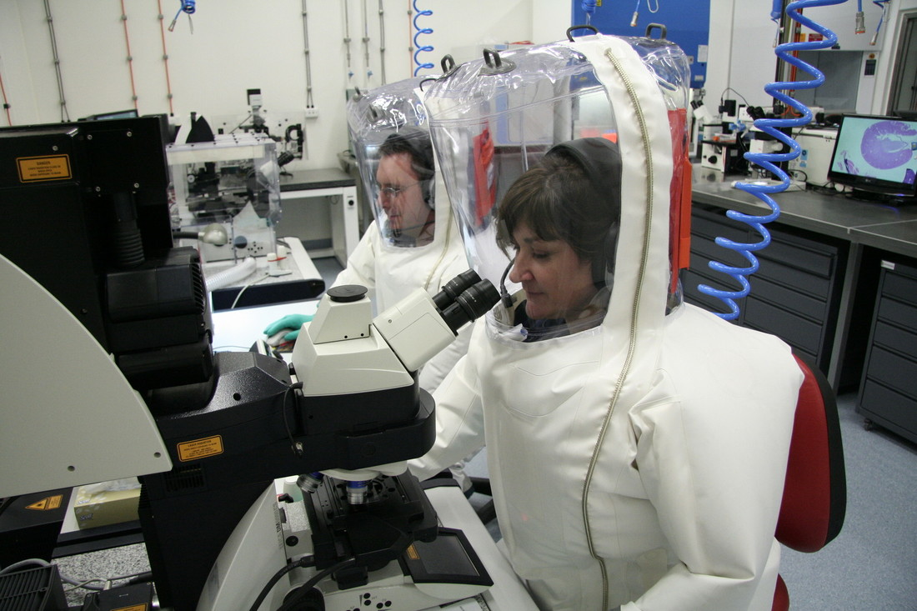

Special and Essential Requirements

The successful candidate will be required to undertake a National Police Clearance or equivalent as well as an Australian Government baseline security clearance (and other potential background checks: medical, character clearance requirements). Please note that individuals with criminal records are not automatically deemed ineligible. Each application will be considered on its merits.

Flexible Working Arrangements

We work flexibly at CSIRO, offering a range of options for how, when and where you work. Talk to us about how this role could be flexible for you. [Work life balance](https://www.csiro.au/en/Careers/The-CSIRO-Experience/Balance).

Diversity and Inclusion

We are working hard to recruit diverse people and ensure that all our people feel supported to do their best work and feel empowered to let their ideas flourish.

We are committed to the safety and wellbeing of all children and young people.

Eligibility

Applications for this position are open to Australian / New Zealand Citizens and Australian Permanent Residents only.

To Apply

As part of the application process, we ask that candidates provide the following:

* **Curriculum Vitae –** outlining relevant aligning career experience and key achievements.
* **Cover Letter or Executive Summary –** outlining the motivation for applying and a high-level snapshot of relevant aligning capabilities and experience. This document should not be longer than two pages.

CSIRO is a values-based organisation.  In your application and at interview you will need to demonstrate behaviours aligned to our values of:

**People First:** We put the safety and wellbeing of our people above all else, and we know that diversity is the compass to navigate innovation. (Respect, Caring, Inclusive)

**Trusted:** We earn trust everywhere, because we deal only in facts, and we operate with unwavering integrity. (Partnering, Cooperative, Humble)

**Further Together:** We collaborate widely and generously to boldly take on challenges that are bigger than ourselves. (Curious, Adaptive, Entrepreneurial)

**Making it Real:** We don't just do research – we deliver solutions that create change in our world. (Accountable, Authentic, Courageous)

**For any questions not answered in this document, please feel free to contact:**

Melanie Pecanek

Executive Talent Acquisition Business Partner

[melanie.pecanek@csiro.au](mailto:melanie.pecanek@csiro.au)

Nicole Poole

Talent Acquisition Team Lead, Future Industries; Energy, Environment & Resources

nicole.poole@csiro.au

**Applications close 11:59pm Australian Eastern Standard Time, January 14th, 2024**

*We encourage early applications as we reserve the right to close the advertising early if we find our desired candidate.*



|  |
| --- |
| As Australia’s national science agency and innovation catalyst, CSIRO is solving the greatest challenges through innovative science and technology.  CSIRO. Unlocking a better future for everyone.  Contact us  1300 363 400  +61 3 9545 2176  csiro.au/contact  csiro.au |
|  |