

Australia’s National  
Science Agency

Information for applicants

**Acknowledgement of Country**

In the spirit of reconciliation, CSIRO acknowledges the Traditional Custodians of country throughout Australia and their connections to land, sea and community. We pay our respect to their Elders past and present and extend that respect to all Aboriginal and Torres Strait Islander peoples today. View our [vision towards reconciliation](https://www.csiro.au/en/about/Indigenous-engagement/Reconciliation-Action-Plan)

**Child Safety**

CSIRO is committed to the safety and wellbeing of all children and young people involved in our activities and programs. View our [Child Safe Policy](https://www.csiro.au/en/about/policies/child-safe-policy).

Deputy / Science Director, Manufacturing

About CSIRO

*The Commonwealth Scientific and Industrial Research Organisation (CSIRO) is Australia's premier research body and National Science Agency. We solve the greatest challenges through innovative science and technology to build prosperity, growth, health, and sustainability for our customers, all Australians, and the world.* [***csiro.au***](https://www.csiro.au/)***.***

CSIRO is one of the world’s largest and most successful publicly funded research and development organisations and one of the most multidisciplinary mission-driven research agencies in the world.

CSIRO solves the greatest challenges through innovative science and technology, and we are committed to complementing our world-class science capabilities with outcome-focussed research to generate and deliver economic, environmental, and social benefits for Australia in a global context.

CSIRO is also Australia’s most trusted research institution and most connected innovator, working with most Australian universities, government and non-government agencies and major Australian industries to co-create commercialisation outcomes that deliver impact and create science-driven technologies and economic value and a better future for all Australians.

Our collaborative research turns science into solutions for food security and quality, clean energy and resources, health and wellbeing, resilient and valuable environments, innovative industries, and a secure Australia and region, securing our future national prosperity as well as environmental and social benefits.

CSIRO acknowledges the extraordinary contributions Aboriginal and Torres Strait Islander people have made, and continue to make, to our culture, the economy and science. We’re working with Indigenous communities and organisations to create Indigenous-driven science solutions that support sustainable futures for Indigenous peoples, cultures, and Country.

CSIRO Strategy & Values

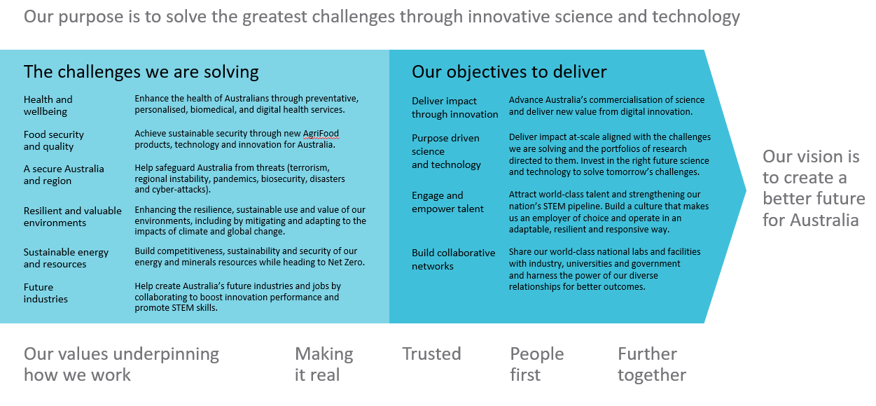

*CSIRO's values are more than just words. They represent what is unique and special about CSIRO and underpin not just the work we do, but how we do it, and how we interact with our colleagues and the diverse range of partners we collaborate with every day.* [*CSIRO’s values - CSIRO*](https://www.csiro.au/en/about/Values)

Leading@CSIRO Framework

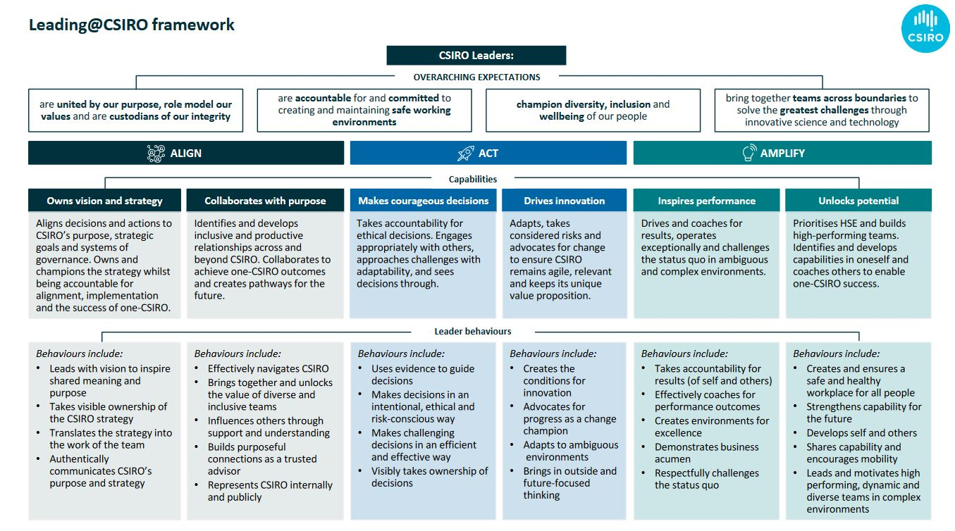The Leading@CSIRO Framework (below) outlines what is expected of all CSIRO leaders.

About the Manufacturing Research Unit

*The Manufacturing Research Unit is industry’s innovation partner, working together to transform and build sovereign capability by developing new processes, materials and products.*

Manufacturing is critical to a modern Australian economy. It currently contributes about six per cent of Australia’s GDP, and is a growing contributor to Australian exports.

At CSIRO we accelerate sustainable, globally competitive manufacturing for Australia through leading-edge, commercially viable and scalable solutions.

The Manufacturing Research Unit’s strategy is helping to galvanise Australia’s manufacturers through world-leading science and engineering and propelling Australian industry to the forefront of high quality, high tech and environmentally sustainable production. It is a bold strategy that drives innovation and supports Australian sovereign capability by responding to the external trends and the shifting requirements of the Australian manufacturing sector. Pivoting to harness digital technologies, CSIRO is directly supporting industry to adopt advanced manufacturing technologies and approaches.

Our research is based on multi-disciplinary scientific and engineering capabilities and uses world-class infrastructure. We partner with industry to develop innovative products and processes that allow Australian manufacturers to be globally competitive and environmentally sustainable.

Our manufacturing and materials research capabilities include:

* new metals and additive manufacturing (3D printing)
* batteries and innovative energy solutions
* advanced polymers, resins and chemicals
* prototyping and engineered systems
* quantum technologies
* vaccines and pharmaceuticals (small molecule and biological)
* medical technologies – drug delivery, biomedical materials and diagnostics
* materials characterisation and modelling

About the Role:

Deputy / Science Director, Manufacturing

|  |  |
| --- | --- |
| Tenure | Specified Term – 3 years, Full-time |
| Salary Range | Attractive salary package negotiable for the right candidate + up to 15.4% superannuation. |
| Location | Clayton, Victoria or Lindfield, Sydney  (And with a willingness and ability to travel interstate and internationally as required). |
| Relocation Assistance | Will be provided to the successful candidate if required. |
| Applications are open to | Australian / New Zealand Citizens, Australian Permanent Residents and existing Australian temporary visa holders with full work rights for the duration of the term |
| Position reports to the | Director Manufacturing |
| Client Focus – Internal | 60% |
| Client Focus – External | 40% |
| Number of Direct Reports | 3 |

Role Overview

The Deputy Director / Science Director Manufacturing will work closely with the Research Unit Director Manufacturing, playing a leading role in the provision of scientific vision, leadership, and direction of the Research Unit to ensure CSIRO is scientifically impactful and competitive.

The Deputy Director / Science Director is a member of the Research Unit Leadership Teamand the CSIRO Science Council (along with the other Deputy / Science Directors across CSIRO) and will deputise for the Research Unit Director as required.

The Deputy Director will collect and apply internal and external intelligence to ensure Manufacturing’s project portfolio drives scientific excellence and leads to impact in line with CSIRO’s research objectives. The role will bring research expertise to drive more focused, impactful work whilst ensuring a portfolio of immediate, medium, and long-term impact research. The Deputy Director will lead activities focused on monitoring, evaluating, and improving the impact of Manufacturing’s portfolio. This role is expected to be active in project scoping and delivery, ranging from early-stage research to commercialisation activities driven by Manufacturing and our partner Research Units.

The role will work closely with the Manufacturing Leadership Team and broader CSIRO leadership regarding management of strategic relationships and alliances with the Business Unit’s partners, both domestic and international, to ensure optimal competitive positioning, organisational alignment, and delivery in the national interest.

To be considered for this exciting leadership role, you will be an engaging leader with a deep knowledge of the research and development sector. You will have exceptional interpersonal, influencing and communication skills combined with a proven ability to form and maintain relationships with executive stakeholders.

Experience in strategic portfolio development and delivery with a visionary approach is a must. You bring demonstrated people leadership capabilities with the ability to empower and facilitate positive and collaborative team relationships and the foresight to anticipate and efficiently resolve complex technical, management and administrative issues.

The Deputy Director / Science Director will:

* oversee the delivery of the Manufacturing Future Science Platforms (FSPs) and Science Leader Programs and engage in other Research Unit led FSPs as required.
* lead the development, implementation and monitoring of the strategic capability plans for people and the scientific infrastructure in line with Manufacturing’s and CSIRO’s strategic objectives.
* work closely with the Manufacturing Leadership Teams to outline and deliver upon the Research Unit’s strategic requirements.
* collaborate with CSIRO’s other Deputy Directors / Science Directors to ensure CSIRO effectively executes its strategy and to ensure the co-management of strategic relationships and alliances, both domestic and international, to ensure optimal competitive positioning, organisational alignment, and delivery in the national interest.
* be responsible for working with Manufacturing’s Research Directors to ensure there is a diverse pipeline of scientific talent to meet existing and emerging CSIRO priorities and will lead the rewards and promotions process for Manufacturing.

The successful Deputy Director / Science Director will bring research expertise to drive more focused, impactful work whilst ensuring a portfolio of immediate, medium, and long-term impactful projects aligned with Manufacturing’s capability.

Duties and Key Result Areas

**Science & Impact Leadership**

* Provide high level strategic leadership to ensure the Manufacturing Research Unit remains globally scientifically competitive.
* Develop and promote a culture of science excellence by focusing on the translation of new ideas through to national and international impact.
* Drive effective development, utilisation, and delivery of Research Unit science capability in accordance with research and investment priorities.
* Contribute as an active member of CSIRO Science Council, providing recommendations to the CSIRO Research Office on mechanisms to secure future science investment and competitive schemes

**Functional Leadership**

* Contribute to strategic and operational planning for the Research Unit, and leadership in the implementation, monitoring, and evaluation of these strategic plans.
* Develop and lead major strategic proposals aligned with the Research Unit’s future science direction and be accountable for leading their implementation, performance, and outcomes.
* Facilitate organisational development by introducing strategies that position the Research Unit to deal with potential challenges and influences on the operating environment.
* Act effectively in the Research Unit Director role as required.
* Effectively lead change through periods of uncertainty.
* Oversight of financials – budgets, forecasting etc.

**Capability & Resource Leadership**

* Strive for “Zero Harm” (physical and psychological) through a commitment to a healthy, safe and environmentally sustainable workplace.
* Shape science capability internally and externally through partnerships and collaborations to meet future science opportunities, program goals and impact pathways.
* Support the Manufacturing Leadership Team in world class talent management, including attraction, succession planning and in prioritisation and deployment of investments.
* Monitor long-term economic and science trends to forecast capability demand and identify medium and long-term plans for scientific infrastructure.
* Adhere to, promote and encourage the spirit and practice of CSIRO’s Values, Health, Safety and Environment plans and policies, Diversity initiatives, and Zero Harm goals.
* Lead, promote and encourage a Quality Assurance; strong governance and compliance driven culture.

**Engagement & Partnerships**

* Develop, manage and maintain relevant external relationships and partnerships to advance CSIRO’s interests, improve science delivery, and to achieve Manufacturing’s strategic goals.
* Engage with government, industry and other relevant industry groups e.g. defence, pharmaceutical.
* Provide high-level scientific representation and advice associated with CSIRO’s cross Research Unit capability, nationally and internationally.
* Create opportunities for cross-Research Unit collaboration on significant national science initiatives and projects.

Required Competencies

* **Teamwork and Collaboration:** Creates and fosters an environment in which there is a high level of cooperation within and between teams. Facilitates positive team relationships to build interactions across Research Units and the organisation.
* **Influence and Communication:** Uses complex influencing strategies, for example, assembling strategic coalitions, building behind the scenes support and the tactical use of information to gain support.
* **Resource Management/Leadership:** Contributes to or defines Research Unit / organisational policy directions, strategic planning and operationalises the vision for staff and gains commitment to the direction chosen. Plans, seeks, allocates resources and monitors to achieve outcomes. Adopts a mentor role.
* **Judgement and Problem Solving:** Resolves major conceptual scientific, technical, commercial or management problems, which have a significant impact upon the field of research, professional function, the Research Unit or the Organisation. Situations faced have little or no precedent and require original concepts and approaches.
* **Independence:** Commits significant resources in the face of uncertainty and takes calculated risks to improve performance and achieve challenging goals. Uses personal energy to drive change strategies. Formulates and implements contingency plans to minimise the impact of potential risks. Accepts personal responsibility for the outcomes of decisions/risks taken.
* **Adaptability:**Is flexible in response to external change or when faced with external constraints. Identifies and promotes the opportunities arising as a result of change.

Selection Criteria

#### Essential

*Under CSIRO policy only those who meet all essential criteria can be appointed.*

* A degree with demonstrated achievement in senior leadership roles within manufacturing research or related sectors, ideally with postgraduate qualifications and a deep understanding of the manufacturing R&D industry.
* Experience working within or across multidisciplinary organisations, with an understanding of complex corporate systems and processes.
* Strong executive engagement and strategic relationship management skills that promote complex multi-stakeholder collaborations and initiatives, foster new opportunities and support national or international outcomes.
* Ability to attract, retain, empower, and develop world-class talent while fostering multidisciplinary teams. Proven leadership capabilities to inspire, empower, and resolve complex technical, management, and administrative issues.
* A proven track record leading complex change initiatives in a collaborative manner.
* Exceptional interpersonal, influencing, and communication skills with strong business acumen, a results-oriented approach, and financial skills.
* Experience in strategic portfolio development and visionary program delivery, with the ability to build cross-organisational capability.

**Desirable**

* Evidence of successful leadership of scientific program delivery in the national interest, at a similar size and scale to the Manufacturing Research Unit.

Flexible Working Arrangements

We work flexibly at CSIRO, offering a range of options for how, when and where you work. Talk to us about how this role could be flexible for you. [Work life balance](https://www.csiro.au/en/Careers/The-CSIRO-Experience/Balance).

Diversity and Inclusion

We are working hard to recruit diverse people and ensure that all our people feel supported to do their best work and feel empowered to let their ideas flourish.

We are committed to the safety and wellbeing of all children and young people.

Eligibility

Applications for this position are open to Australian / New Zealand Citizens, Australian Permanent Residents and Australian temporary visa holders who currently hold a valid visa for the duration of the term.

To Apply

As part of the application process, we ask that candidates provide the following:

* **Curriculum Vitae –** outlining relevant aligning career experience and key achievements.
* **Cover Letter or Executive Summary –** outlining the motivation for applying and a high-level snapshot of relevant aligning capabilities and experience. This document should not be longer than two pages.

CSIRO is a values-based organisation.  In your application and at interview you will need to demonstrate behaviours aligned to our values of:

**People First:** We put the safety and wellbeing of our people above all else, and we know that diversity is the compass to navigate innovation. (Respect, Caring, Inclusive)

**Trusted:** We earn trust everywhere, because we deal only in facts, and we operate with unwavering integrity. (Partnering, Cooperative, Humble)

**Further Together:** We collaborate widely and generously to boldly take on challenges that are bigger than ourselves. (Curious, Adaptive, Entrepreneurial)

**Making it Real:** We don't just do research – we deliver solutions that create change in our world. (Accountable, Authentic, Courageous)

**For any questions not answered in this document, please feel free to contact:**

Nicole Poole

Executive Talent Acquisition Business Partners

nicole.poole@csiro.au

**Applications close 11:59pm Australian Eastern Standard Time, Sunday 30th March 2025**

*We encourage early applications as we reserve the right to close the advertising early if we find our desired candidate.*

|  |
| --- |
| As Australia’s national science agency and innovation catalyst, CSIRO is solving the greatest challenges through innovative science and technology.  CSIRO. Unlocking a better future for everyone.  Contact us  1300 363 400  +61 3 9545 2176  csiro.au/contact  csiro.au |

