Position Details

Technical Services – CSOF2 – CSOF4
The following information is for applicants
Advertised Job Title | Multiple Roles in Technical Support and Launcher Operations – New Norcia Deep Space Tracking Facility
Job Reference | 100440
Tenure | Specified Term of 5 years  Full-time, Part-time, or Job-share (min hours required)
Salary Range | AU$67k (CSOF2.5) - AU$96k (CSOF4.1) per annum (pro-rata for part-time)  plus up to 15.4% superannuation  *Note: Salary level will be dependent on experience and skill level  New Norcia staff receive a $10K per annum (pro-rata for part-time) site allowance in addition to base salary
Location(s) | New Norcia Deep Space Tracking Facility
Relocation Assistance | Will be provided to the successful candidate if required
Applications are open to | Australian/New Zealand Citizens and Australian Permanent Residents
Position reports to the | New Norcia Maintenance and Operations Manager
Client Focus – Internal | 10%
Client Focus – External | 90%
Number of Direct Reports | 0
Enquire about this job | Suzy Jackson via email at Suzy.Jackson@csiro.au or phone +61 8 9654 4418
How to apply | Apply online at https://jobs.csiro.au/  Internal applicants please apply via Jobs Central  If you experience difficulties when applying, please email careers.online@csiro.au or call 1300 984 220.

Acknowledgements
Acknowledgement of Country

CSIRO acknowledges the Traditional Owners of the land, sea and waters, of the areas that we live and work on across Australia. We acknowledge their continuing connection to their culture and pay our respects to their Elders past and present. View our vision towards reconciliation.
Acknowledgement of Yued Noongar Country
CSIRO acknowledges the Yued people as the traditional owners of the country that New Norcia Deep Space Ground Station is built on.

Child Safety
CSIRO is committed to the safety and wellbeing of all children and young people involved in our activities and programs. View our Child Safe Policy.

CSIRO Values
Visit CSIRO Online and Space and Astronomy and for more information. In your application and at interview you will need to demonstrate behaviours aligned to our values of:
- People First
- Further Together
- Making it Real
- Trusted

Flexible Working Arrangements
We work flexibly at CSIRO, offering a range of options for how, when and where you work. Talk to us about how this role could be flexible for you.

Diversity and Inclusion
At CSIRO, diversity, equity, and inclusion are at the core of who we are. They are fundamental to our mission and to our impact. We understand that diverse perspectives drive innovation and helps us to better understand the complex challenges we seek to solve at CSIRO.
Inclusion underpins how we treat our team at CSIRO. Therefore, we're continuing to build a safe and welcoming culture where people can bring their whole selves to work and ensure that everyone at CSIRO feel supported to do their best work and feel empowered to let their ideas flourish. Our success rests on our ability to acknowledge and understand intersectionality, recognising the diverse experiences, identities, relationships and social factors that shape each individual. By fostering a thriving culture that embraces differences, we believe in, and respect, the power of diverse perspectives and learn from the uniqueness of our people.

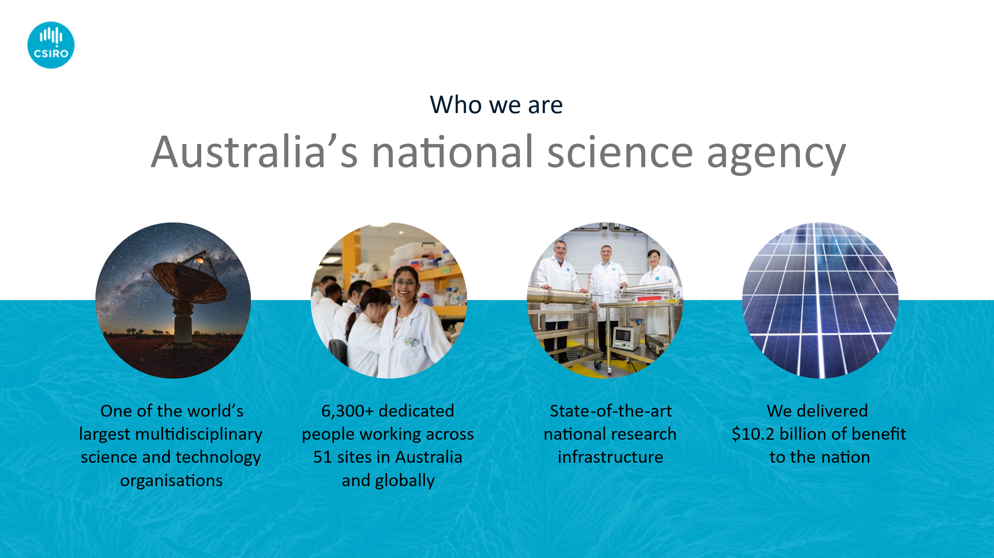
About CSIRO

CSIRO (Commonwealth Scientific and Industrial Research Organisation) is Australia’s national science agency and innovation catalyst and one of the world’s largest and most successful publicly funded research and development organisations.
CSIRO is one of the largest and most multidisciplinary mission-driven research agencies in the world. With 53 locations and over 6,300 people across Australia and internationally, CSIRO solves the greatest challenges through innovative science and technology to deliver world-class economic, environmental, and social benefits for Australia in a global context.
Many of CSIRO’s innovations were once considered impossible. Fast WiFi, Aerogard insect repellent and the plastic Australian banknote, to name a few.
Until someone, just like you, joined us and took on the challenge.
We are committed to developing and supporting a diverse workforce in its broadest sense and know diverse teams are more effective and deliver more innovative outcomes for science.
As an employee of CSIRO, you will be eligible for the many benefits of working at Australia’s National Science Agency. You can read more here:
- Life at CSIRO
- Personal Development and Learning
- Generous Leave Conditions
- Work / Life Balance

About New Norcia Deep Space Tracking Facility
Located 130 kilometres north-east of Perth in Western Australia, the New Norcia ground station is one of three deep space stations in the European Space Agency (ESA)'s tracking station network; the other two are located in Cebreros, Spain and in Malargüe, Argentina.
Deep Space
New Norcia hosts two 35-metre deep space antennas; NNO1, constructed in 2001, and NNO3, which is expected to begin operations at the end of 2025. The deep space antennas provide support to ESA's missions exploring our Solar System and observing our galaxy and Universe. They track their locations, send control commands, and reliably receive their scientific data gathered hundreds of millions of kilometres from Earth.
Some of the missions supported at New Norcia include:
- BepiColombo, which was launched in October 2018 and is on its way to explore Mercury – the closest planet to our Sun – where it will endure temperatures in excess of 350°C
- Mars Express, which is currently orbiting the Red Planet collecting information about its geology, atmosphere, surface environment, history of water and potential for life
- ExoMars Trace Gas Orbiter, which is sampling the Martian atmosphere for methane and other atmospheric gases that are present in small concentrations and performing a vital data relay function for rovers and landers on the surface
- Juice, which is on its way to Jupiter to make detailed observations of the giant gas planet and its three large ocean-bearing moons – Ganymede, Callisto and Europa
In addition to supporting ESA missions, the station provides tracking support to scientific and interplanetary missions operated by other space agencies like NASA and Japan's JAXA under resource-sharing agreements.
Launcher Tracking
Using its smaller, 4.5-m diameter antenna, NNO-2, the New Norcia station also provides critical tracking services for Ariane 6 and Vega C rockets launched from Europe's Spaceport at Kourou, French Guiana.
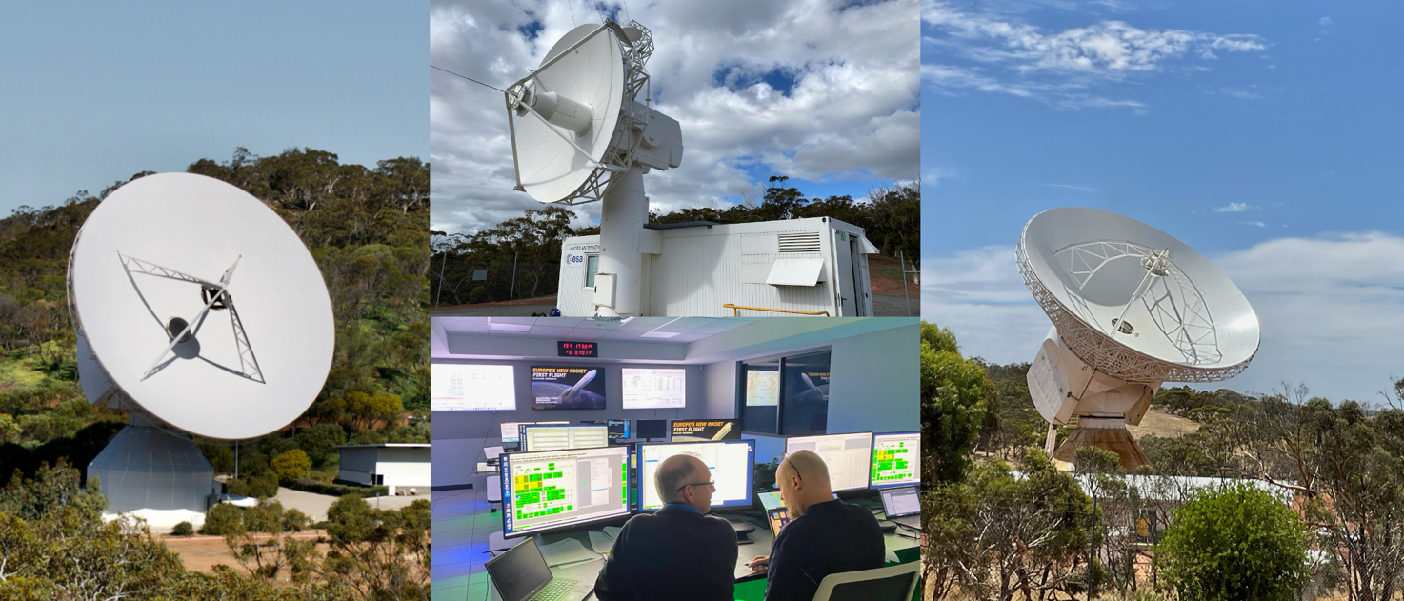

Role Overview
New Norcia Deep Space Tracking Facility is expanding operations to support our second large deep space antenna, and to support CNES (the French National Centre for Space Studies) and the European Space Agency’s increasing program launching satellites from the Kourou Spaceport by providing tracking services. We are well on our way to becoming the largest deep space tracking station in the ESA network, with a range of uplink and downlink bands that gives us the ability to track the full range of deep space missions.
New Norcia station hosts a wide array of electronic, RF, computing, cooling, antenna drives and power equipment necessary to communicate with spacecraft.
As part of our expansion, we are seeking enthusiastic, skilled people to add to our capabilities and to embark on a rewarding career in the space industry.
You will work alongside a team of skilled and dedicated technicians and engineers to maintain the station, provide logistics support, and support launcher activities. You will be given the opportunity to learn and understand the equipment and processes used for deep space and launcher tracking.

Most of our staff live in Perth, and we maintain a pool of shared vehicles to transport staff to New Norcia.
Our roles are as diverse as the people we are seeking, and include:
- Day-to-day maintenance of specialised tracking station equipment including IT systems, RF and electronics systems, servo drives, power and HVAC systems.
- Operations support of rocket launcher tracking, including occasional out-of-hours site attendance.
- Creation and ongoing review of station documentation for quality provision of services and ensuring compliance with health and safety systems.
- Liaising with our colleagues in Europe to facilitate shipment of equipment between the station and ESA headquarters,
- Working with the systems for configuration and asset management for the station.

Specifics of the roles will be tailored to your skills, qualifications and competencies, and CSIRO is expecting to provide you with significant professional development, plus assistance with tertiary studies. Our goal is to pass the baton on to the next generation of professionals.
CSIRO value and respect difference, and we are committed to building an inclusive culture by creating an environment where you can balance a successful career with your commitments and interests outside of work. We believe that you will do your best at work if you have a work / life balance. We are open to discussing flexible working opportunities with this role being offered on a full-time, part-time or job share basis. Please raise your preference in your application.

Duties and Key Result Areas
- Maintenance Work: Under general supervision, undertake a range of technical tasks requiring skills which have been developed through experience or training to maintain station IT systems, RF systems, and electronics systems. Some work at New Norcia involves working at heights on antennas.
- Installation Work: Assist with occasional installation activities, including installation of cables, fibre and electronics systems under supervision.
- Operational Needs: Work during maintenance periods to a high standard to ensure the station is operational at the end of a short time window.
- Launcher Activities: Participate in occasional rocket launcher activities, including work outside normal hours.
- Logistics: Assist with logistics activities involving shipping materials between New Norcia Station and Europe.
- Documentation: Assist with the development of technical documentation, quality systems and safe work instructions.
- Communication: Communicate openly, effectively and respectfully with all staff, clients and suppliers in the interests of good business practice, collaboration and enhancement of CSIRO’s reputation.
- Professionalism: Adhere to CSIRO’s Values, Code of Conduct, Health, Safety and Environment procedures and policy and diversity initiatives.
- Additional Duties: Undertake any other reasonable tasks or duties as directed to ensure the continued reliable operation of the facility.

Selection Criteria
CSIRO is an Equal Opportunity employer committed to building a diverse and inclusive workplace — one that reflects the communities we serve and where everyone feels respected, valued, and able to thrive. We welcome applications from people of all backgrounds, cultures, abilities, and identities – including Aboriginal and Torres Strait Islander peoples, people from culturally and linguistically diverse backgrounds, people living with disability, and people of all genders and sexual orientations. If you require adjustments to participate in the recruitment process or the role itself, we are here to support you.
Under CSIRO policy only those who meet all essential criteria can be appointed.

Essential
- Relevant Qualifications: Certificate of year 12 high school education.
- Additional Qualifications: Applicants with completed or significant progress towards trade qualifications, diploma or bachelors degree qualifications in relevant technical fields such as engineering, IT or science may be eligible for appointment at higher grades.
- Experience: Applicants with significant STEM experience may be appointed to higher grades.

Desirable
- Skillset: Aptitude in Science, Technology, Engineering or Maths fields.
- Installation Activities: Experience in installation activities and maintenance of cabling and optical fibre, or electronics equipment.
- Working on Structures: Ability and desire to work at heights.

Required Competencies
- Teamwork and Collaboration: Demonstrates initiative, actively contributing as a team member. Supports team decisions and keeps other team members up to date about individual actions. Shares all relevant and useful information. Pitches in and helps other team members when necessary.
- Influence and Communication: Communicates basic facts in a courteous manner including posing appropriate questions to gain factual information.
- Resource Management/Leadership: Provides instruction and assists other staff to complete allocated tasks and activities.
- Judgement and Problem Solving: Selects appropriate solutions to clearly defined problems using readily available information. Alternatives are limited and prescribed or apparent.
- Independence: Accepts personal responsibility for doing the job well. Looks for opportunities to improve the way things are done and makes recommendations accordingly.
- Adaptability: Accepts the need for change to work routines or technology.
Special Requirements
The successful candidate will undertake a pre-employment background check. Please note that individuals with criminal records are not automatically deemed ineligible. Each application will be considered on its merits.

