Position Details

Technical Services - CSOF5
The following information is for applicants
Advertised job title | ASKAP Electronics Engineer
Job reference | 102280
Tenure and work schedule | Indefinite  Full-time or part-time (minimum of 0.8 FTE) | 5-day work week with regular onsite travel
Salary range | AU$118,102 – AU$127,808 per annum (pro-rata for part-time) plus 15.4% super across two capability levels. Remote area allowances and close call allowances apply when deploying to the remote site.
Location(s) and office arrangements | Geraldton, WA. (Nhanhangardi, Naaguja, Wilynyu and Amangu Country)  (requires frequent travel, typically of 5 days duration, to the Inyarrimanha Ilgari Bundara, our Murchison Radio-astronomy Observatory, a nationally recognised, world-class observatory, 350km N-E of Geraldton, in Wajarri country)
Relocation assistance | Will be provided to the successful candidate if required
Applications are open to | Australian/New Zealand Citizens and Australian Permanent Residents
Position reports to the | Team Leader ASKAP, Space & Astronomy
Client focus – Internal | 90%
Client focus – External | 10%
Number of direct reports | 0
Enquire about this job | Contact Brett Hiscock, via email at Brett.Hiscock@csiro.au
Support and workplace adjustments | We offer a range of reasonable supports and workplace adjustments. Please let us know via email at careers.online@csiro.au if we can help you to equitably participate in our recruitment process or the role itself.
How to apply | Apply online at https://jobs.csiro.au/  Internal applicants please apply via Jobs Central  If you experience difficulties when applying, please email careers.online@csiro.au
Acknowledgement of Country

CSIRO acknowledges the Traditional Owners of the land, sea and waters, of the areas that we live and work on across Australia. We acknowledge their continuing connection to their culture and pay our respects to their Elders past and present. View our vision towards reconciliation.
Diversity, inclusions & belonging
At CSIRO, diversity, equity, and inclusion are central to our purpose and impact. We value diverse perspectives, which drive innovation and help us address complex challenges.
Inclusion is key to our culture, ensuring everyone feels supported and empowered to contribute their best work. We recognise the intersectionality of experiences, identities, and social factors that shape each individual. By embracing diversity, we learn from the uniqueness of our people, creating a culture where all belong. CSIRO is an equal opportunity employer, recruiting based on merit and reflecting the community we serve. We value diversity in all its forms, including age, nationality, ability, culture, gender, sexuality, faith, education, and thought.

About CSIRO
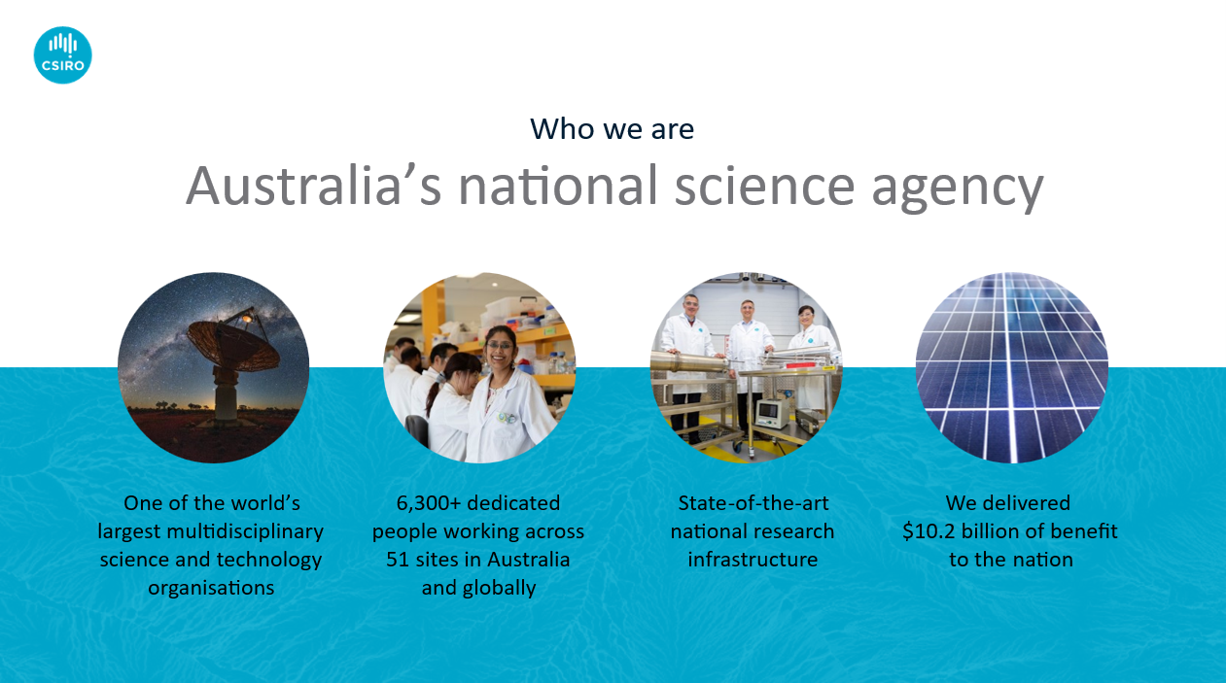
As Australia's national science agency, CSIRO is solving the greatest challenges through innovative science and technology. Many of our iconic innovations were once considered impossible until someone, just like you, joined us and took on the challenge.
As one of the world’s largest multidisciplinary mission-driven research organisations, we are focused on the issues that matter the most: for our quality of life, for the economy and for our environment. We believe diverse teams are more effective and deliver more innovative outcomes. When we all focus on the big things that really matter, and work in partnership with our communities and Indigenous Australia, Australian science and technology can solve seemingly impossible problems and create new value for all Australians. Visit CSIRO.au for more information.

About the ASKAP radio telescope
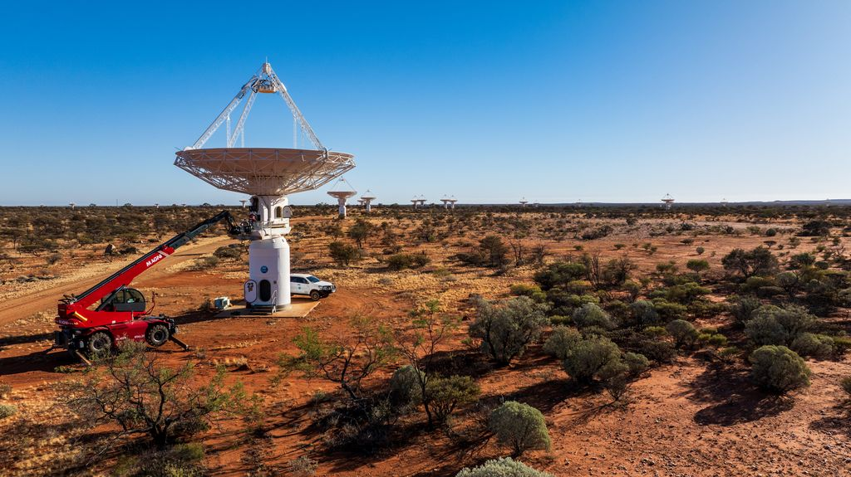

ASKAP is located at Inyarrimanha Ilgari Bundara, the CSIRO Murchison Radio-astronomy Observatory and managed out of Geraldton in Western Australia. The radio telescope array consists of 36 parabolic antennas, each 12m in diameter, that works together as a single astronomical interferometer. It is used by astronomers to map the universe above it to unprecedented depths of sensitivity, and completed a rapid survey of the entire sky from 2019 to 2020 that mapped three million galaxies. ASKAP’s current five-year program aims to discover new galaxies, investigate galaxy formation and evolution, and discover fast radio bursts and other transient sources with increased sensitivity.

The suite of 36 antennas are fully-steerable, and equipped with novel Phased Array Feed (PAFs) receivers designed and built by CSIRO. These receivers together produce 100Tb/s of raw data which are processed on site using state-of-the-art digital signal processing hardware, also designed and maintained by CSIRO. Exceptionally high volumes of data are transported to the Pawsey Supercomputing Research Centre in Perth, where data is ingested and transformed into science-ready data products. Visit ASKAP radio telescope - CSIRO for more information.

Role overview
The role of Technical Services staff in CSIRO is to provide support for scientific research in a diverse range of laboratory and field situations across a range of different research projects. This support consists of the application of accepted technical practices and the development of new practices. The work is usually carried out as a member of a centralised service.
CSIRO’s Space & Astronomy research unit seeks a highly motivated and appropriately skilled Professional Engineer to lead a small technical team whose primary purpose is to provide support for the radio frequency and digital electronic systems which form part of the Australian Square Kilometre Array Pathfinder (ASKAP) radio telescope.
The successful candidate will contribute to the operation of ASKAP as a world-class scientific instrument, and the observatory as a world-class facility to host other Radio-astronomy instruments. The ASKAP instrument comprises modern Phased Array Feeds and digital hardware to beam form and correlate received Radio Frequency wavefronts from astronomical sources. A strong ability to support state-of-the-art digital and radio frequency electronic systems is essential. This position requires both technical leadership and the ability to diagnose complex electronic systems.
This is an Engineering Operational position based at the Murchison Support Facility (MSF) in Geraldton. Frequent travel will be required to the observatory in the Murchison, where the ASKAP radio telescope is located, some 350km northeast of Geraldton. Visits will be typically five days in duration and require overnight stays at the Boolardy accommodation facility. The incumbent will supervise directly three technical staff and work closely with other engineering and support staff.
This is an opportunity to combine the advantages of a relaxed, ocean-side lifestyle with a leading-edge technology job at a world-class science and technology research facility.
CSIRO S&A is committed to providing a safe and inclusive work culture and implementing initiatives to improve diversity and equity within our workplaces. This role is offered on a full‐time or part‐time basis.
To be successful in this position, you will have a proactive approach to your duties, an eye for detail and the ability to lead a small technical team. Your solid grounding in digital and analogue electronics will include in-depth fault-finding experience to board level. Ideally, you will also have significant experience in one or more disciplines of high-speed digital electronics, fibre optic data transmission or radio frequency systems. You will demonstrate effective liaison with professional peers, management and a pleasant manner in dealing with client stakeholders. This is an opportunity to be part of a dedicated team supporting an exciting new project with unique and interesting technical challenges, combined with the benefits of living in a vibrant regional community.

Duties and key result areas
- Provide professional engineering support for ASKAP electronic systems, both radio frequency and digital processing hardware.
- Support the full range of ASKAP electronic systems.
- Under the guidance of the ASKAP Team Leader, supervise a small technical team performing engineering commissioning and maintenance work on the electronic systems that comprise and support the ASKAP telescope. This will include:
  - Technical leadership of the team,
  - Identifying critical issues,
  - Contributing to the resolution of routine and complex telescope operational problems,
  - Scheduling, budgeting and planning maintenance activities for electronic systems on the ASKAP array and the support systems at the MSF.
- Ensure the availability of ASKAP electronic spares and consumables to minimise telescope downtime and other operational disruptions.
- Demonstrate effective liaison with professional peers, management and a pleasant manner in dealing with client stakeholders.
- Manage electronic workspaces to ensure safe and fit-for-purpose, including appropriately maintained and calibrated laboratory test equipment.
- Ensure electronic equipment faults and repairs are reported and tracked, maintain preventative maintenance documents, engineering documentation and drawings, and develop test/repair procedures when required.
- Contribute to the safe and efficient conduct of team activities, with Geraldton colleagues and observatory visitors, and other external stakeholders.
- Contribute to capability enhancements, resource savings, health, safety and environmental initiatives, including safe work methods.
- Frequent travel to the Observatory where the ASKAP radio telescope is located, 350km northeast of Geraldton.
- Communicate openly, effectively and respectfully with all staff, clients and suppliers in the interests of good business practice, collaboration and enhancement of CSIRO’s reputation.
- Work collaboratively as part of a multi-disciplinary, often regionally dispersed research team, and business unit to carry out tasks in support of CSIRO scientific objectives.
- Adhere to CSIRO’s Code of Conduct, Health, Safety and Environment plans and policies, Diversity initiatives and Zero Harm goals.
- Other duties as directed.

Selection criteria

Essential
Under CSIRO policy only those who meet all essential criteria can be appointed.
- An Engineers Australia-accredited four-year electronic/electrical engineering qualification plus work experience at the level of Professional Engineer
- Demonstrated understanding and practical skills in analogue and digital electronics systems relevant to radio astronomical operations, with a specialisation in either low noise Radio Frequency electronics, or high speed digital processing electronics including both hardware and firmware for systems built around Field Programmable Gate Array (FPGA) technology.
- Self-motivated, with demonstrated ability to apply professional engineering judgement in the course of commissioning, maintaining and/or designing and upgrading of electronics systems, from systems down to first-principles ‘hands-on’ board level;
- Ability to lead a small technical team consisting of staff with various backgrounds and skill levels;
- Demonstrated ability to identify the source of system deficiencies and apply innovative solutions to technical, logistics and team challenges whilst working in a remote area for extended periods;
- Demonstrated ability to communicate technical information including interpret and prepare circuit diagrams, technical specifications, drawings and reports and generally to communicate effectively, in writing and face-to-face, with the team, CSIRO management and external stakeholders;
- Commitment to safe work practices, to environmental sustainability and the principles of equity and diversity.
- A current driver’s license and willingness to travel to other CSIRO ATNF sites;
- Ability to work at heights.

Desirable
- Training and experience relevant to work in a remote area (eg. First Aid, 4WD).
- Prior experience with fault report and tracking systems, Altium Design tools and familiarity with the Linux operating system environment.

Not sure if you need all the criteria?
While it is CSIRO policy that the successful candidate must meet all the essential criteria, there are many ways to demonstrate this. Don’t let the list discourage you. If you are unsure about applying, please reach out to the contact on page 1 of this document so we can discuss the role further.

Required competencies
- Teamwork and collaboration: Cooperates with others to achieve organisational objectives and may share team resources in order to do this. Collaborates with other teams as well as industry colleagues.
- Influence and communication: Uses knowledge of other party's priorities and adapts presentations or discussions to appeal to the interests and level of the audience. Anticipates and prepares for others reactions.
- Resource management/leadership: Sets up and maintains effective and efficient work teams and manages performance and resources, to achieve objectives. Chooses appropriate management strategies and communication styles to maintain high levels of motivation and productivity. Gives feedback for development purposes and provides support and direction for improvement.
- Judgement and problem solving: Investigates underlying issues of complex and ill-defined problems and develops appropriate response by adapting/creating and testing alternative solutions.
- Independence: Plans, sets and works to meet challenging standards and goals for self and/or others. Recognises where endeavours will make the most impact or difference, decides on desired outcome and sets realistic goals to reach this target.
- Adaptability: Copes with ambiguity or situations that lack clarity. Adapts readily to changing circumstances and new responsibilities (which may include activities outside own preferences) in the interests of achieving team objectives. Recognises the need for and undertakes personal development as a result of changes.

Setting you up for success
We understand that not everyone works in the same way and sometimes people may require reasonable support and adjustments to perform at their best. Whether related to the recruitment process and or the role itself, this may include options such as providing different methods of communication, flexible hours or physical adjustments to work methods. If you feel comfortable, we encourage you to share any support and adjustments you may need to carry out the inherent requirements of the role. Please reach out to careers.online@csiro.au if we can help you to equitably participate in our recruitment process or the role itself.

Life at CSIRO and flexible working arrangements
We work flexibly at CSIRO, offering a range of options for how, when and where you work. We can discuss flexible work arrangements with you during the recruitment process. CSIRO also offers a range of leave entitlements, benefits and career development opportunities. To learn more, visit Careers at CSIRO.

We celebrate the uniqueness of our workforce and are committed to creating diverse and inclusive teams where everyone feels they belong. CSIRO is an equal employment opportunity organisation dedicated to recruiting people based on merit, and reflecting the diversity of the community we serve. We recognise true diversity encompasses all ages, nationalities, abilities, cultures, genders, sexualities, faiths, levels of education, diversity of thought and many more aspects of identity. By empowering diverse teams, our community is reflected in the solutions we create.

CSIRO values
CSIRO is a values-based organisation committed to values-based leadership.

Value | Descriptor | Behaviour
People first | Our priority is the safety and well-being of our people. We believe in, and respect, the power of diverse perspectives. We seek out and learn from our differences. | - Respectful  - Caring  - Inclusive
Further together | We achieve more together than we ever could alone. We listen and collaborate, in teams, across disciplines, across boundaries. We embrace ambiguity and use discussion and persistence to generate unique solutions to complex problems. | - Accountable  - Authentic  - Courageous
Making it real | We do science with real impact. We thrive when taking on the big challenges facing the world. We take educated risks and defy convention. We celebrate successes and failures and leverage them to learn as we strive to be the force for positive change. | - Partnering  - Cooperative  - Humble
Trusted | We’re driven by purpose but remain objective. We fight misinformation with facts. We earn trust everywhere through everything we do. We trust each other and we hold each other accountable. Together our actions drive Australia’s trust in CSIRO. | - Curious  - Adaptive  - Entrepreneurial

Child safety
CSIRO is committed to the safety and wellbeing of all children and young people involved in our activities and programs. View our Child Safe Policy.
Special requirements
Appointment to this role is subject to the provision of a pre-employment background check and may be subject to other security/medical/character clearance requirements.

- The successful candidate will undertake a pre-employment background check. Please note that individuals with criminal records are not automatically deemed ineligible. Each application will be considered on its merits.
- Due to the specific duties and/or conditions associated with this role, it is essential that the preferred applicant can climb stairs and ladders and work on structures at height of up to 25m.
- The successful candidate must be willing and able to work and travel outside of normal hours on occasion as part of an after-hours/on-call support system, and to assist with upgrades and maintenance. Overtime pay and/or flex leave will be applicable as per policy.

